**Serial Sectioning PSOCT-2P system Manual**

Shuaibin(Stephan) Chang, [shuaibin@bu.edu](mailto:shuaibin@bu.edu)

07/02/2021

**Contents**

* Introduction
* Operating modes
* Step by step manual
* Manual actions in Mosaic and Slicing mode

1. **Introduction**

The serial sectioning PSOCT-2P system is composed of a Polarization Sensitive Optical Coherence Tomography (PSOCT), a Two Photon Microscopy (2P) and a custom-build vibratome. The PSOCT system uses a swept light source (AxsunTech) with 100kHz swept rate, a central wavelength of 1310nm and a full width half maximum (FWHM) spectrum of 110nm, yielding an axial resolution of 5.6um in brain tissue (n=1.4). A polarization controller (Thorlabs) and a polarization beam splitter (PBS) ensures maximum power input with horizontal polarization. A 50:50 beam splitter (BS) separates the beam equally onto the sample arm and reference arm. For the sample arm, an achromat quarter-wave plate (QWP) is placed in front of the sample arm at 45 degree with respect to the input polarization to ensure circular polarization on the sample. A variable retarder is used to compensate the birefringence from the optics in the sample arm, ensuring pure measurement of tissue birefringence. A pair of galvo mirrors, a 4x telescope consists of a custom scan lens (f=50mm) and a tube lens (f=200mm), and a 4x objective (Olympus, UPLFLN4x, NA=0.13) provides 5um theoretical lateral resolution. After double pass the sample arm, the returning light obtains an arbitrary elliptical polarization state depending on the sample’s birefringence. For the reference arm, a linear polarizer (LP) was placed in front of the reference arm at 45 degree with respect to the input polarization to ensure equal power at horizontal and vertical polarization states. We use LP instead of QWP because QWP introduces strong internal reflections that contaminate the image. A retroreflector is used at the end of the reference arm to back-reflect the light. The back-reflected light from sample arm and reference arm interfere with each other and are split by two PBS into horizontal and vertical polarization states, which through two pairs of balanced detector, results in the balanced detection of the co and cross polarization interference pattern. To acquire the spectrum in even-k space, the k-clock of the light source is fed into a high-speed digitizer (ATS9350, AlazarTech) as a sampling trigger. A Graphic Processing Unit (RTX4000, NVIDIA) is used to perform real-time FFT. The post-objective power was measured to be 3.7mW, achieving a 95dB SNR in both polarization states. For this study, a 3x3mm2 FOV was used with 3um lateral step size and 10% overlap between tiles, a compromise between larger FOV, less distortion and faster imaging speed. With such configuration, a 2x2x1cm3 brain block can be imaged within 24 hours.

The 2P microscope consists of a Ti:Sapphire mode-locked laser with 80MHz rep rate, 100fs pulse duration and approximately 4W laser power. An attenuator consists of a motorized half-wave plate (HWP) and a PBS is used to modulate the laser power into the microscope system. A 1.5X beam expander consists of two achromat lens with focal length 100mm and 150mm expands the beam size to fill the objective’s back aperture. A pair of galvo mirrors, a 4x telescope consists of a scan lens (SL50-2P2, f=50mm) and a tube lens (TTL200MP, f=200mm), and a 4x objective (Olympus, UPLFLN4x, NA=0.13) provide 3um theoretical lateral resolution and about 60um axial resolution. Two detection channels are available, one is 435-485nm and the other is 500-700nm.



Figure . Mechanical layout of PSOCT-2P with XYZ stages and vibratome

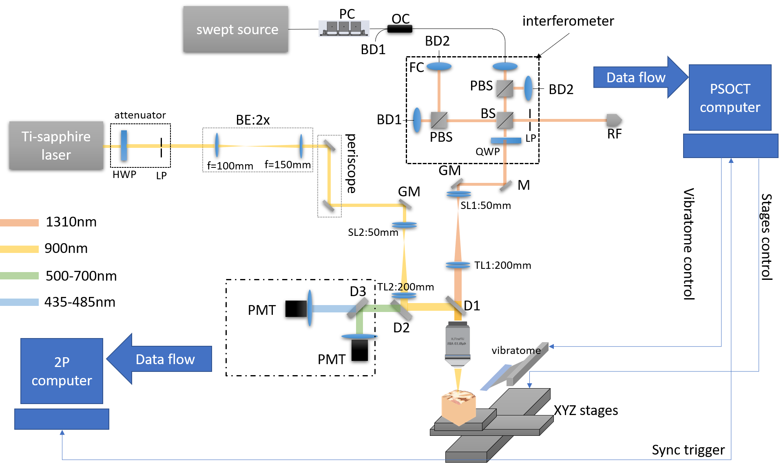

Figure . Optical layout of PSOCT-2P system

The hybrid system works in a master-slave fashion, with the PSOCT being the master and 2P being the slave. At the start of each frame of PSOCT, a start trigger is sent to 2P to simultaneously acquire a 2P frame. When 2P finishes, a finish trigger will be sent to PSOCT so that next frame can start. In this way we make sure there’s no loss of 2P frames when 2P takes more time than PSOCT to acquire a frame. The XYZ motorized stages, the 2P attenuator and the custom vibratome are also controlled by the PSOCT software. With that been said, if 2P is turned off, PSOCT will have no problem doing its own acquisition. And while 2P alone can not do tiling or slicing, it can take single frames independently.

The most powerful function of this system is to do simultaneous 2P and PSOCT imaging of a large block tissue using serial sectioning scheme. In which case the 2P and PSOCT will image the whole surface of the block by tiling. Once the surface is imaged, vibratome will cut off the superficial layer, and then 2P and PSOCT can image the next layer. Repeating in these steps, one is able to image a sample as large as 5x4x2.5cm.

1. **Operating modes**

Various acquisition modes have been implemented to accommodate different experiment requirements, especially for PSOCT.

For 2P, it uses scanimage to control the Galvo scanning and PTM signal digitization. It **can not** control XYZ stages or vibratome. So scanimage is limited to zoom in/out, change pixel dwell time, change number of pixels, etc.

For PSOCT, there are much more configurations. Before diving into details, it is worth to note that two types of FFT are enabled in the system: GPU based FFT and digitizer based FFT (aka, Alazar FFT). GPU FFT retrieves the spectral domain data from the digitizer and send it to a GPU for fast FFT. GPU FFT uses single precision and can perform FFT on both channels simultaneously. Alazar FFT uses 16bit FFT, which seems to toss away some sensitivity and can only work on single channel. Generally, for checking sample boundary and find focus, use Alazar FFT. For real data acquisition, use GPU FFT. In addition, spectral domain data acquisition is also enabled, in which case no FFT is performed. Currently the following acquisitions are supported:

1. Acquiring an averaged B-line from at least 20 B-lines. This mode can run either once or continuously. Real-time visualization is available. This mode is very useful when finding focus, adjusting focusing depth and adjusting the retro mirror. This mode uses the Alazar FFT.
2. Acquiring a single C-scan. This mode can run either once or continuously. Real-time visualization of AIP is available. This mode is useful when finding the block boundary for tiling. This mode can use Alazar FFT or GPU FFT. But for checking boundary, recommend using Alazar FFT.
3. Tiling, aka, acquiring a grid of C-scans with pre-defined mosaic coordinates. This is typically used when imaging the surface of a large sample when no slicing is needed. Both Alazar FFT and GPU FFT are available, but for real data acquisition recommend using GPU FFT.
4. Imaging a block of sample with serial sectioning. This mode involves tiling and cutting, you will need to define cutting and imaging XYZ positions, the following case study will guide you through that. Both Alazar FFT and GPU FFT is available, but for real data acquisition recommend using GPU FFT.

Also note that for GPU FFT, you can choose to save amplitude only or save both amplitude and phase, which will generate more data. *At the time when this manual is written, the phase measurement isn’t ready due to the jittering of digitizer, so there’s no point of saving phase. But if the phase issue is solved in the future, no software change is needed to measure phase.*

Another note for A-line and B-line averaging is supported, use the *pixel dwell time[clock cycles]* and *Line averages* for A-line and B-line averaging, respectively.

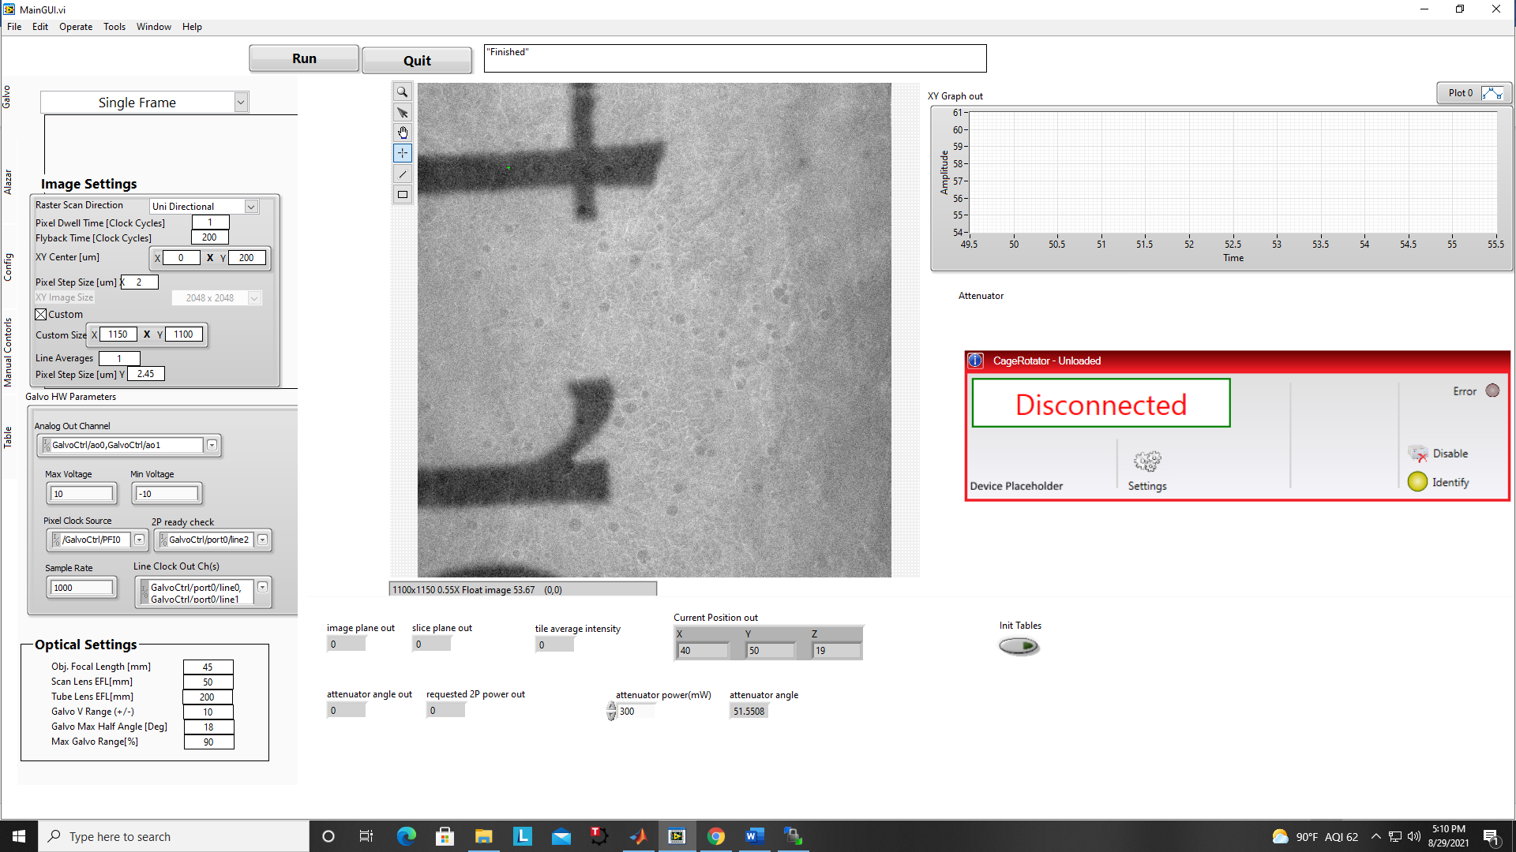

1. **Step by step manual**

We use MainGUI to control PSOCT, stages, vibratome and 2P attenuator. MainGUI is written in Labview, on the left you can find five panels: Galvo, Alazar, config, Manual Controls, and Table. To start mainGUI, click on the arrow button at the top-left of the UI. To Run acquisition, click on the Run button at top of the UI. To stop acquisition, click the Quit button at the top of the UI. To pause acquisition in Moasic mode or Mosaic&slice mode, click on the pause acquisition button located at top of manual control panel.

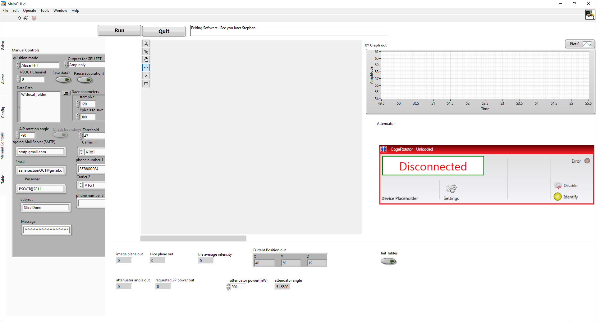

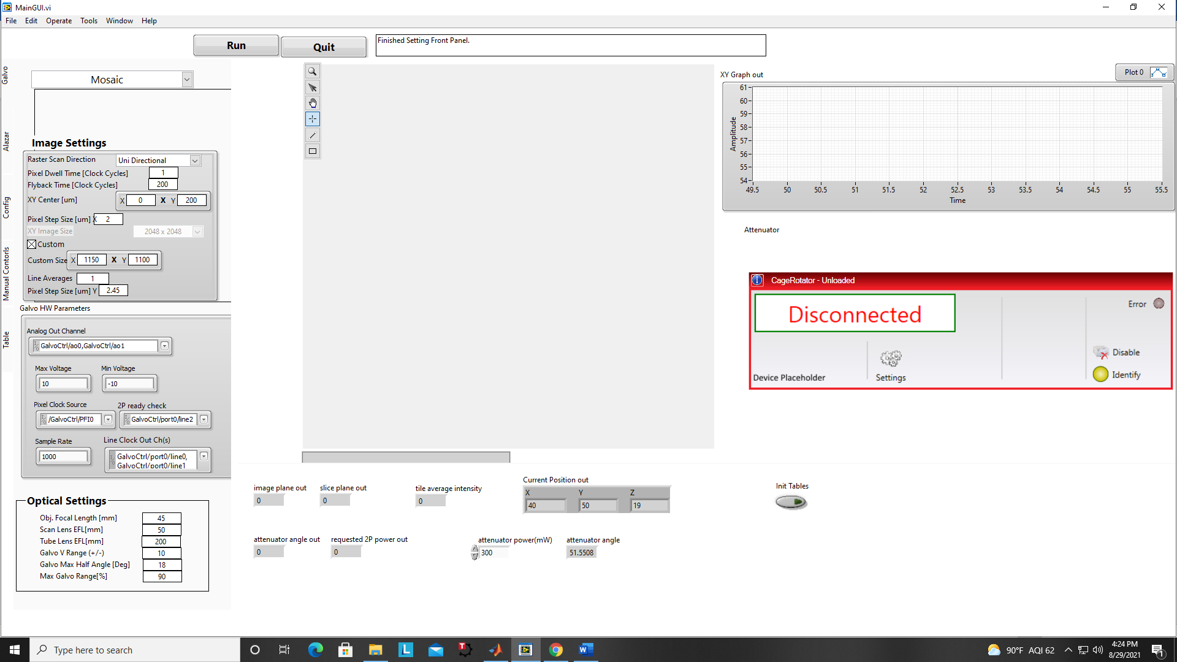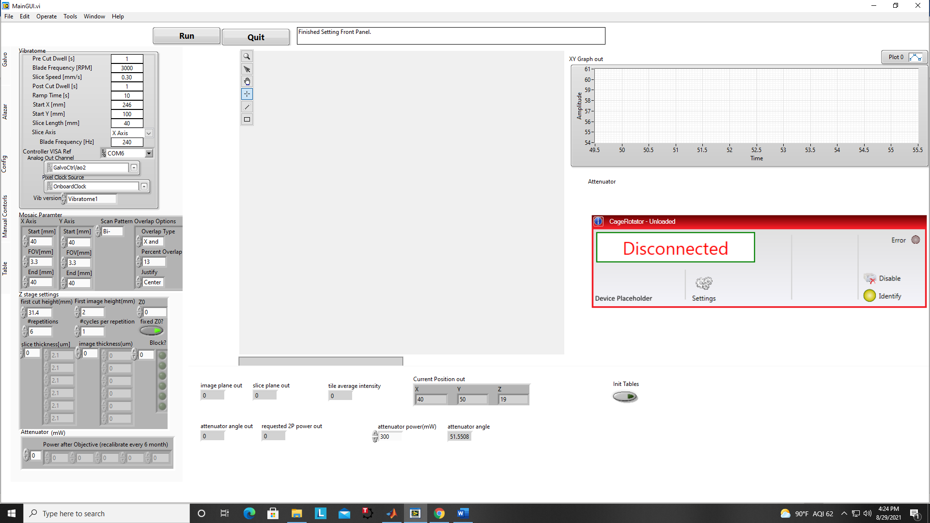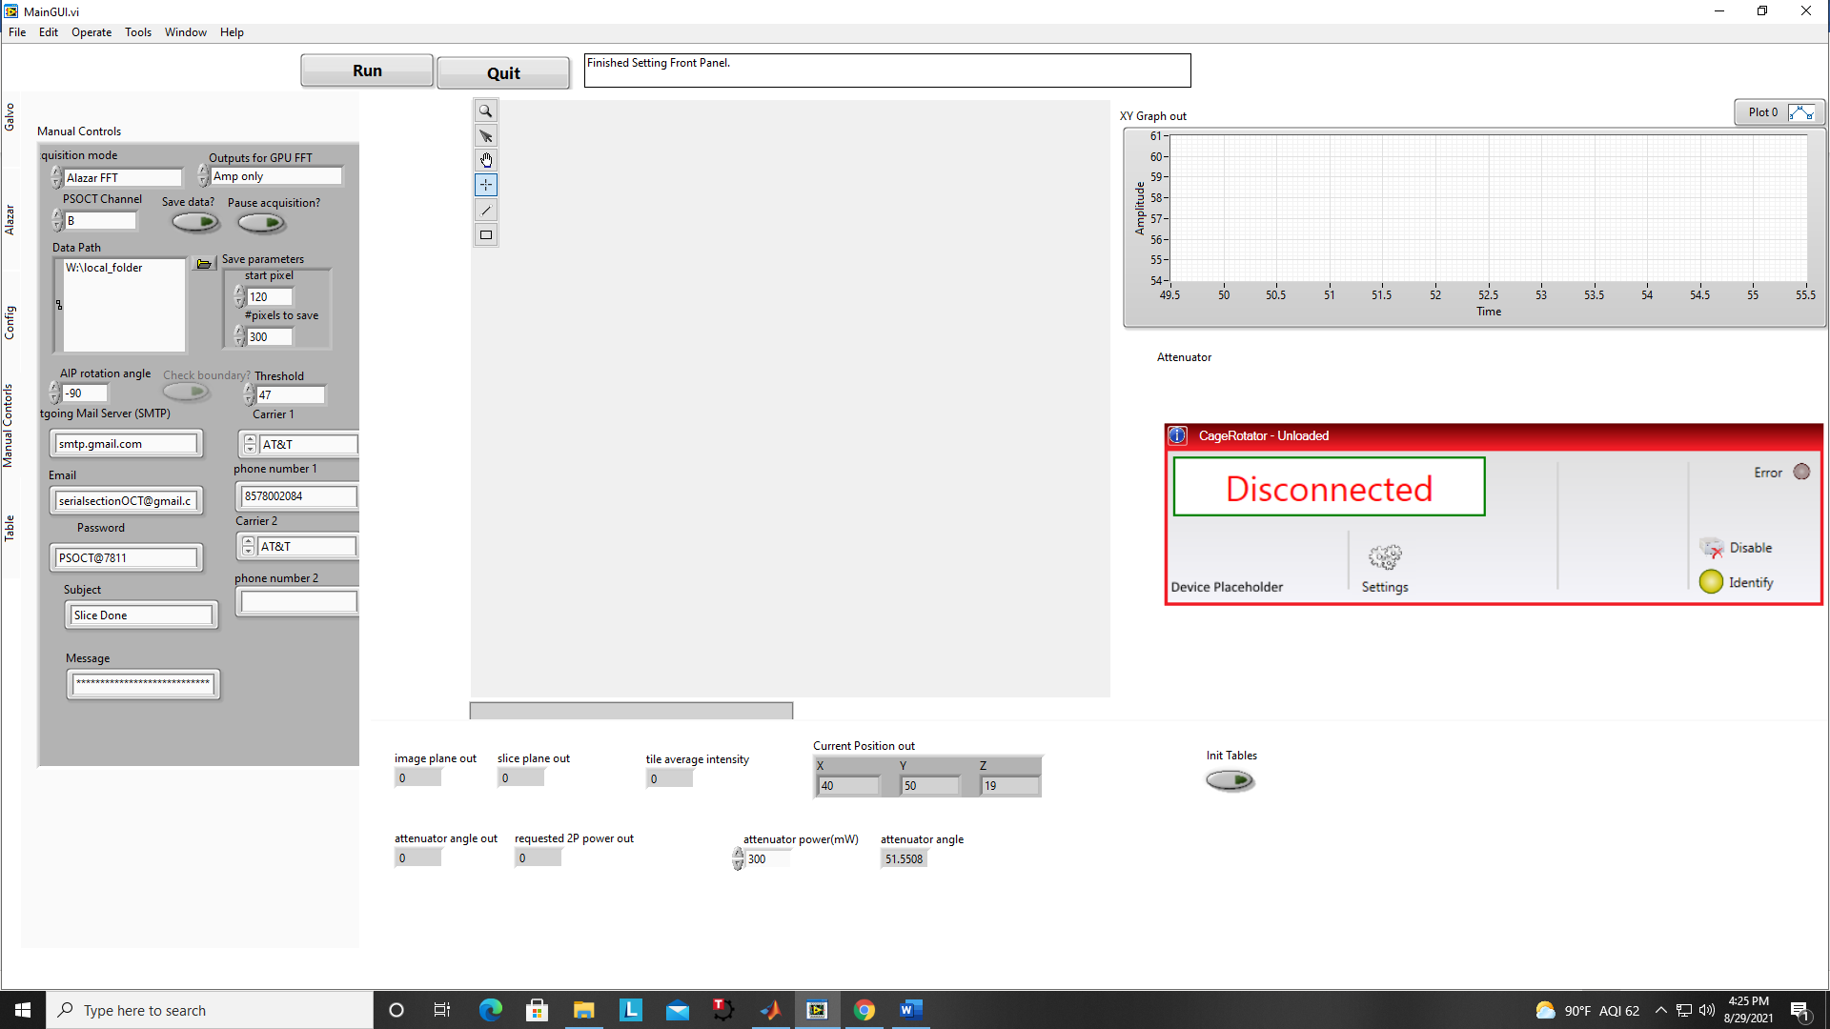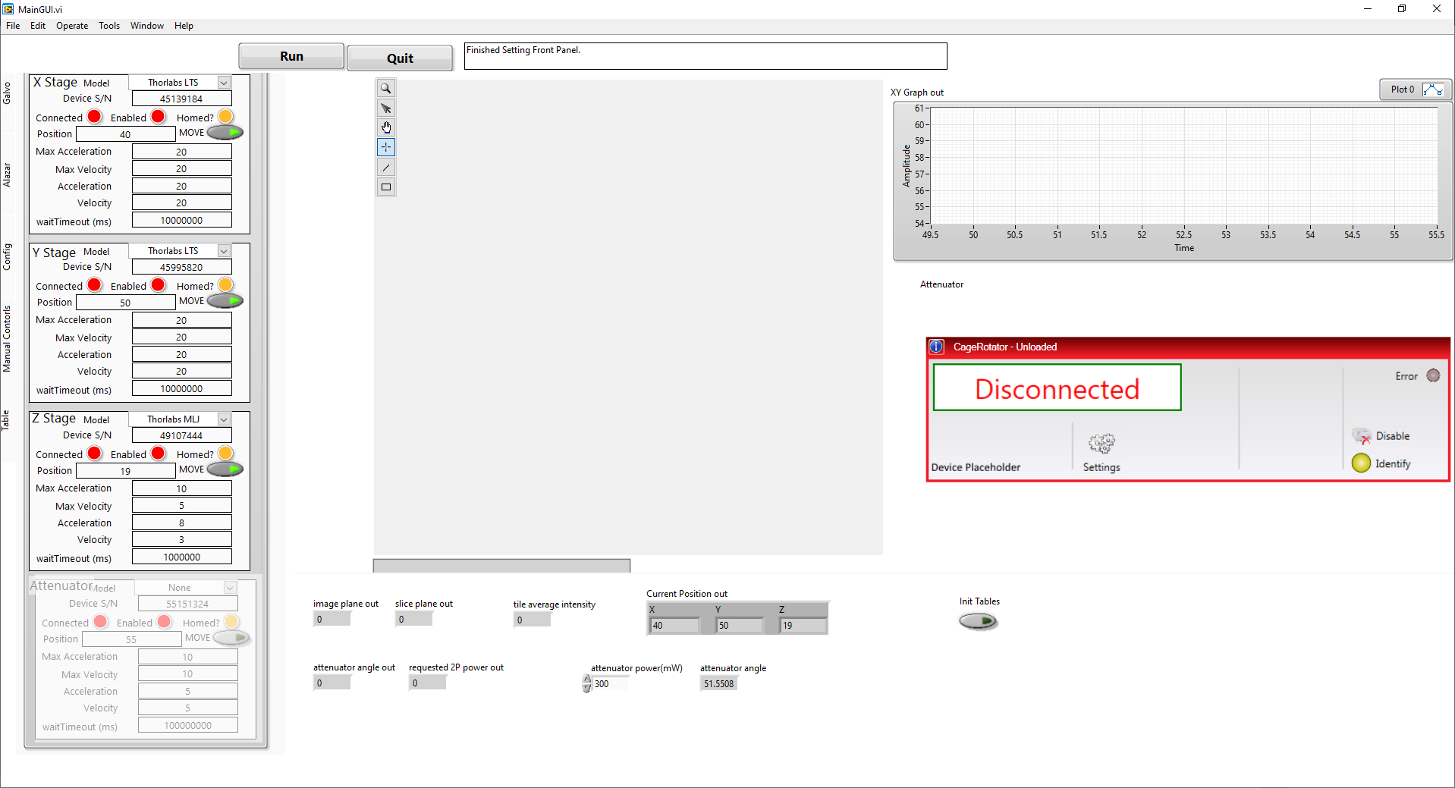

The general steps of block-face imaging are that: first you need to embed the sample and mount it to the XYZ stages, then you need to cut off the superficial agar to expose the brain tissue underneath, after that you need to put tissue in focus and find the XY boundaries for the block, lastly define image depth and slice thickness, and ready 2P before run the experiment. Next we’ll walk through the details of each step.

1. Adjusting variable retarder (skip this step if you have recently adjusted it)

Step 1. Turn on the PSOCT light source and use a glass slide as sample under the objective

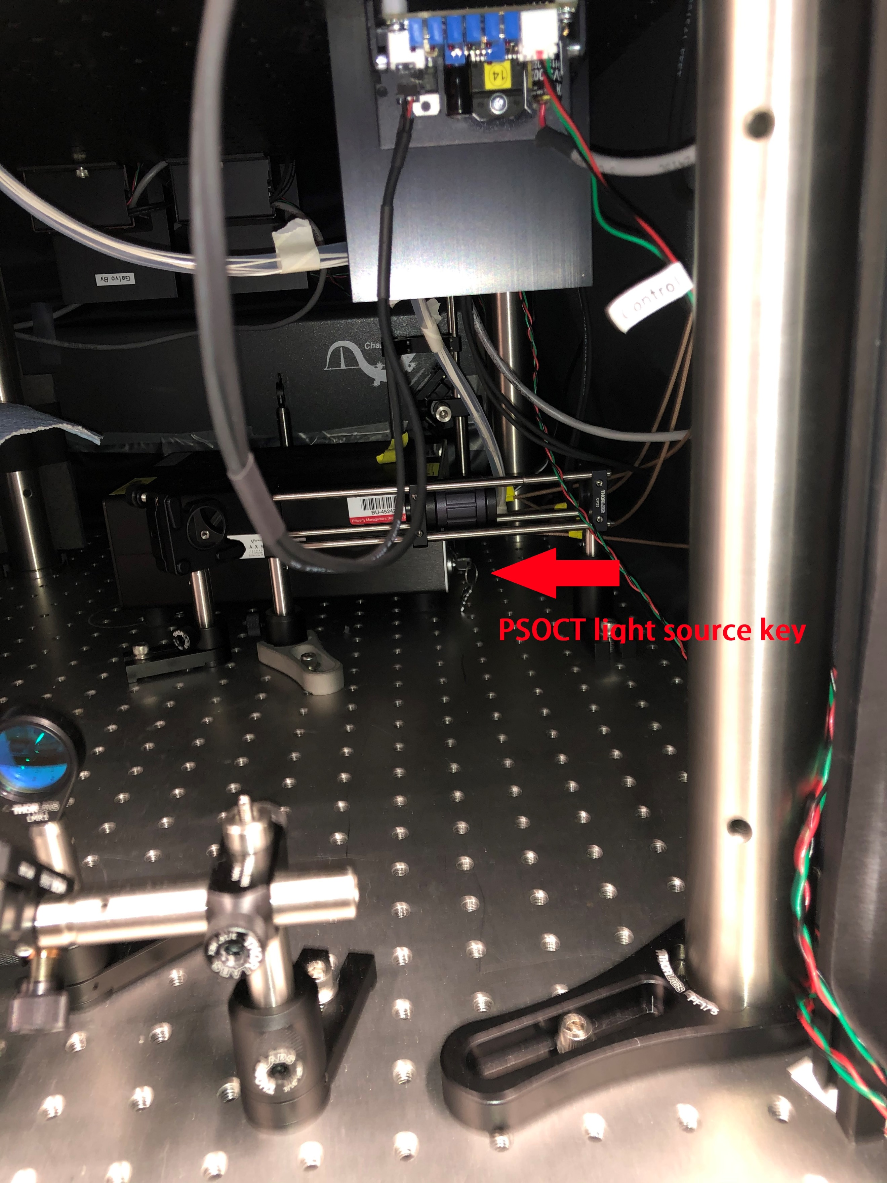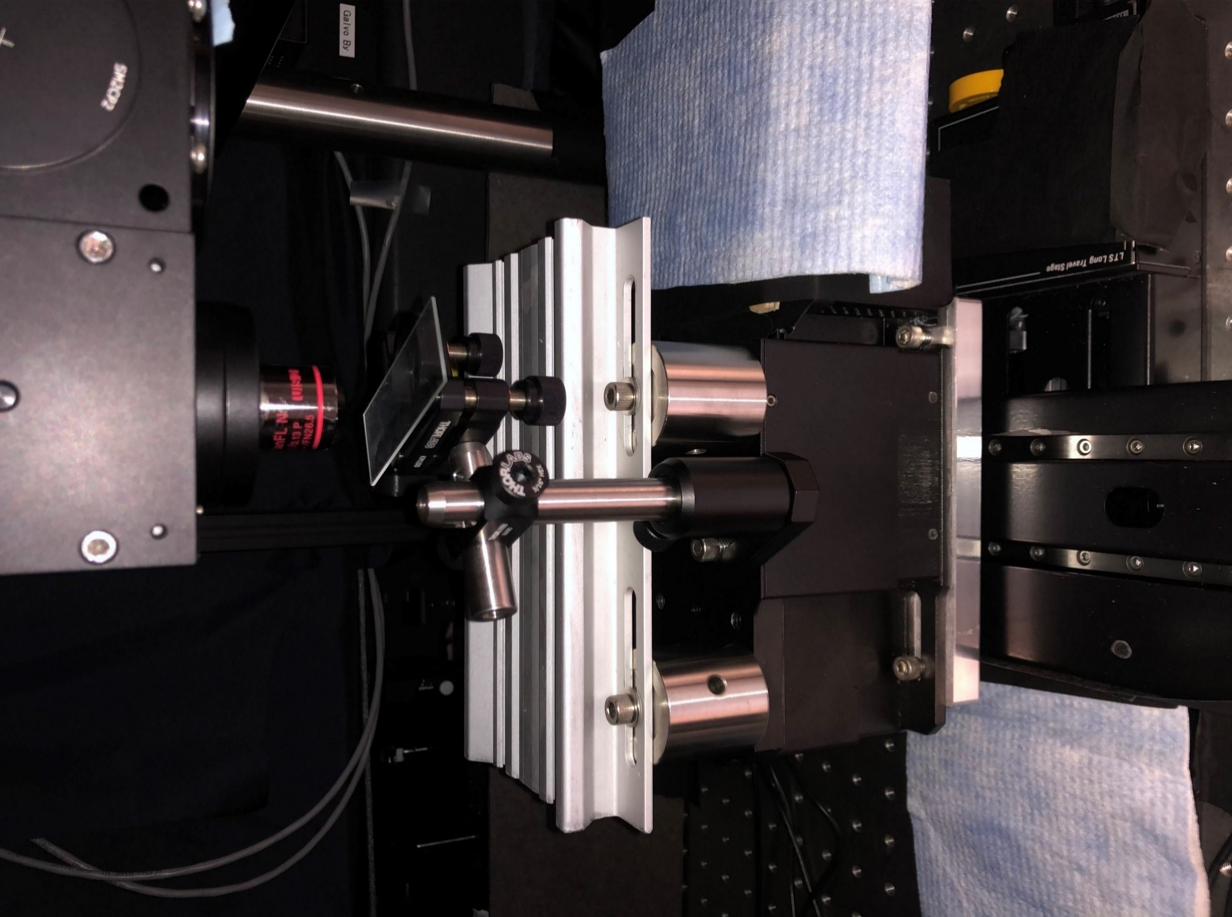

Step 2. While using the AlazarDSO to look at the glass slide signal, open mainGUI and click *Init Stages*, using the Table panel to move the XYZ stages and put the upper surface of glass in focus (remember to use the upper surface, not bottom surface)

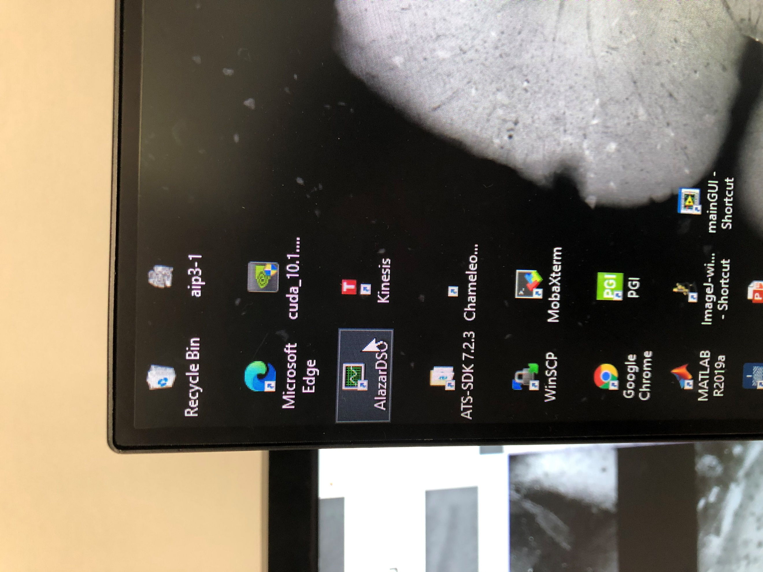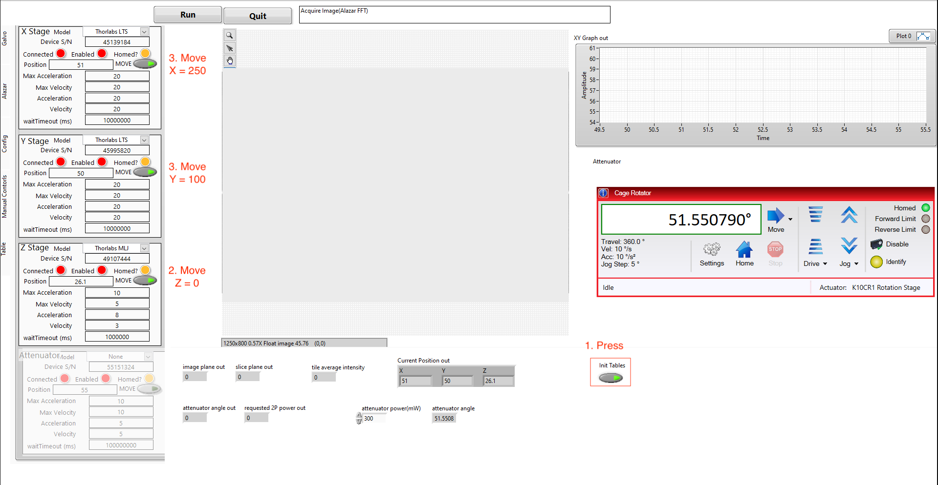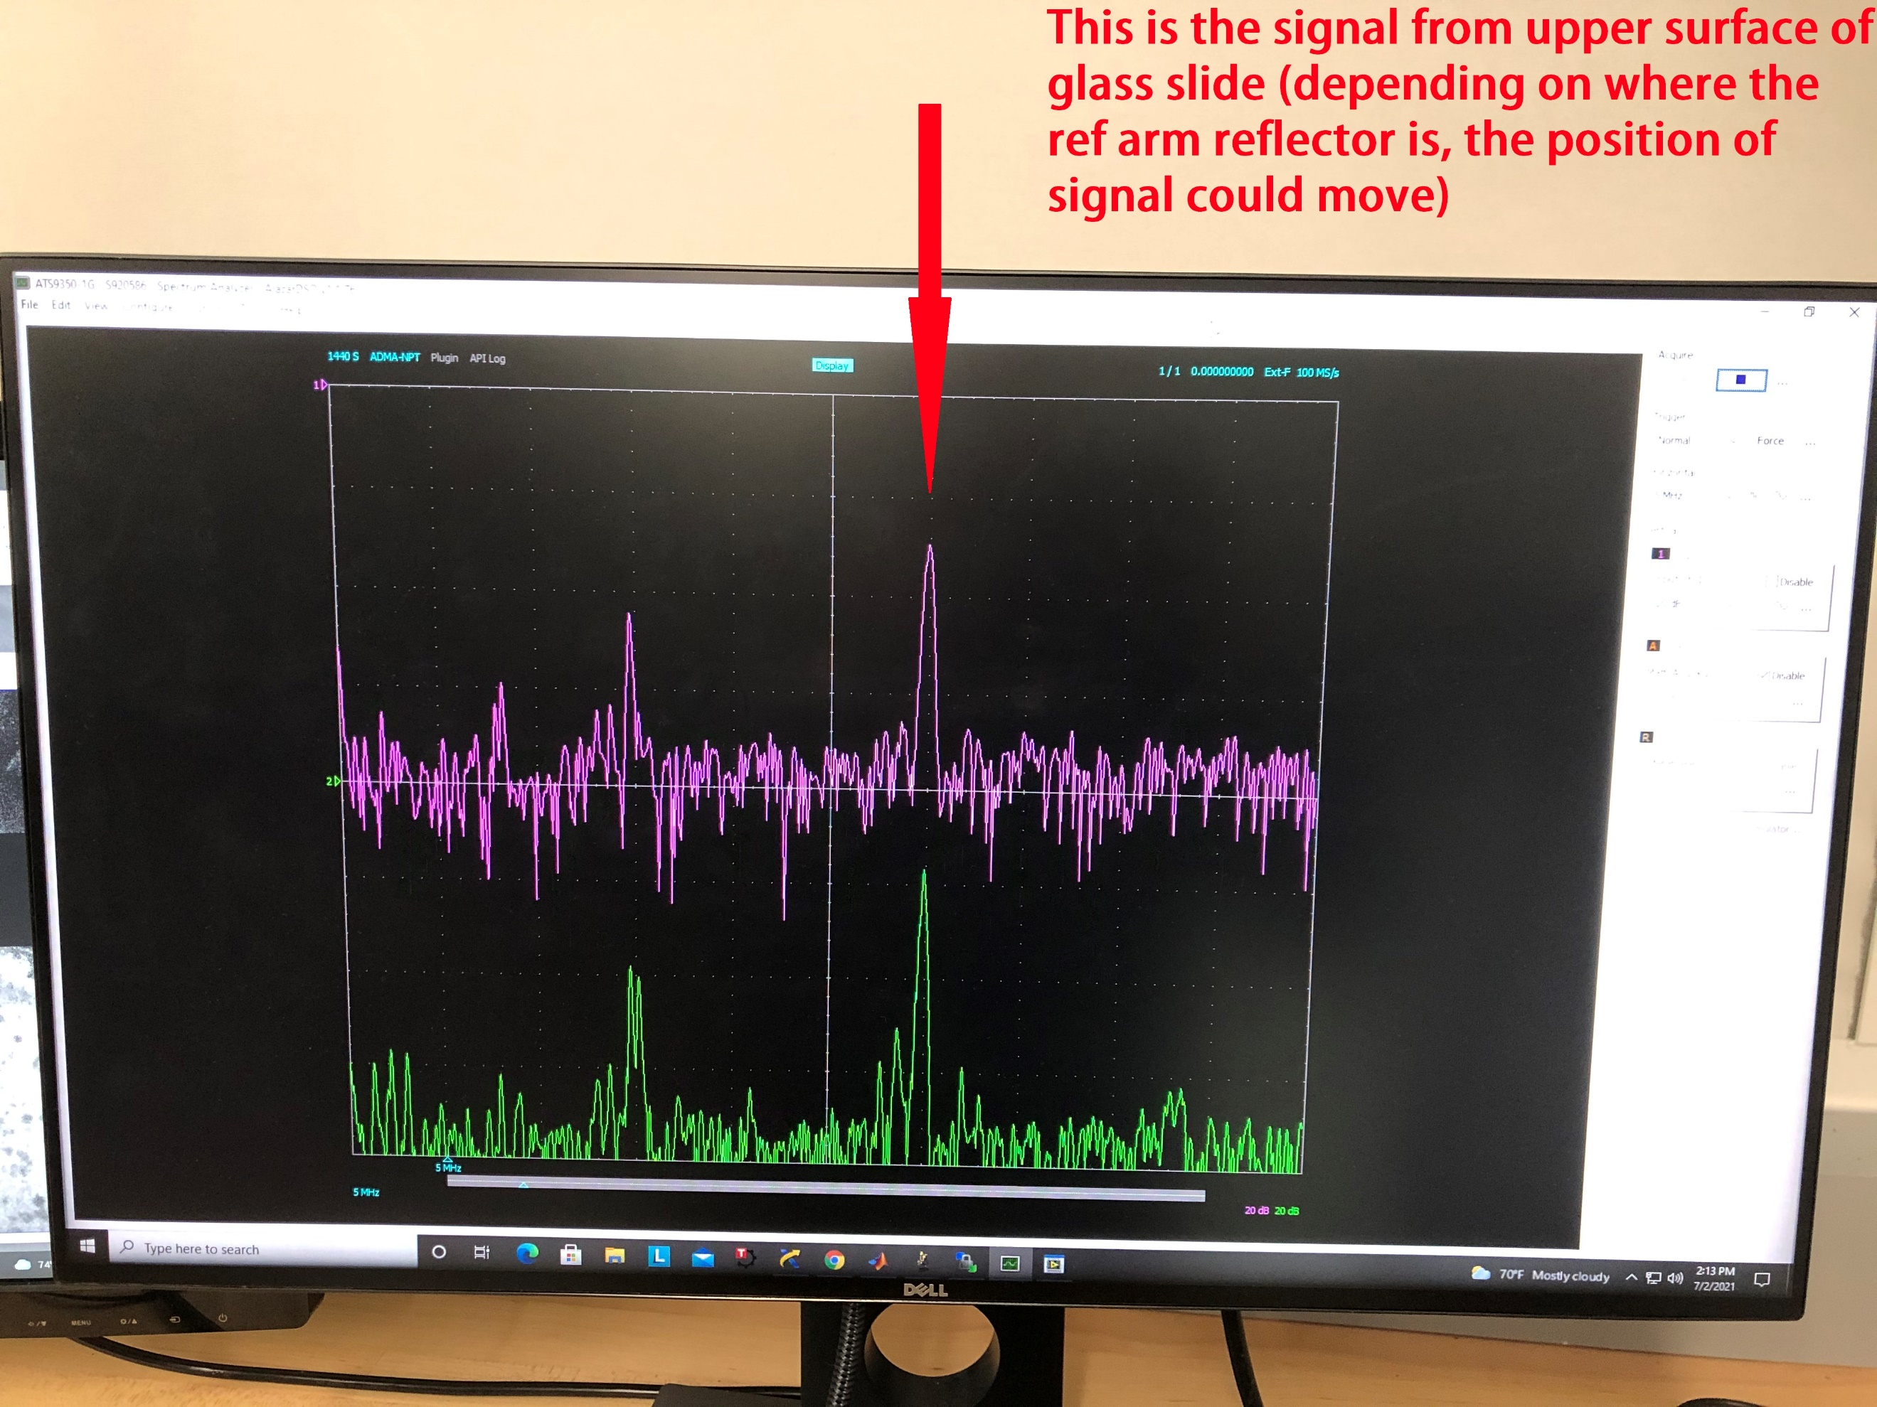

Click to Init Tables

Step 3. Turn on the controller for variable retarder and adjust the voltage to minimize the channel A (pink) in AlazarDSO

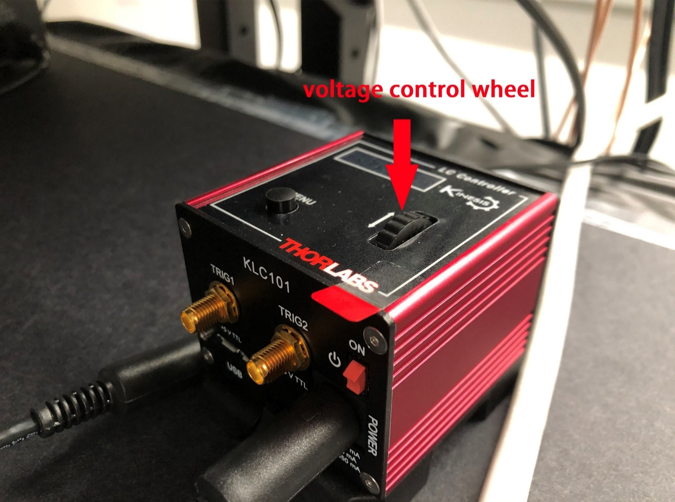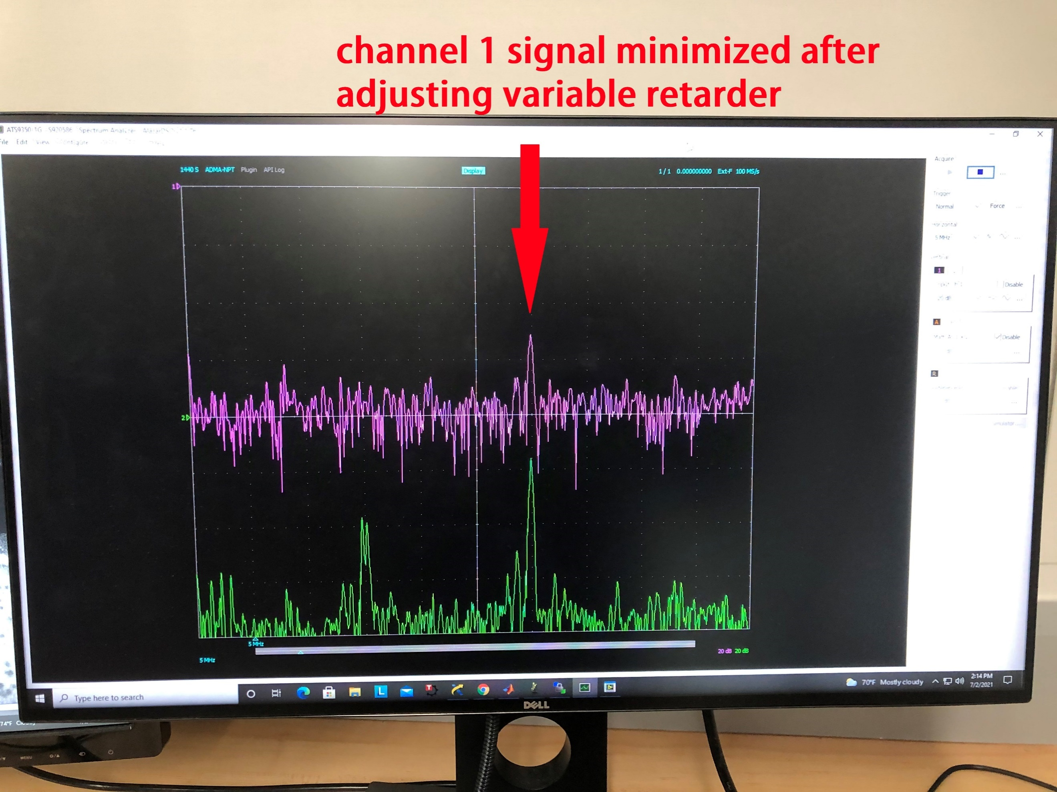

1. Embedding and Mounting sample

Step 1. Pick one set of embedding mold and agar base depending on the sample size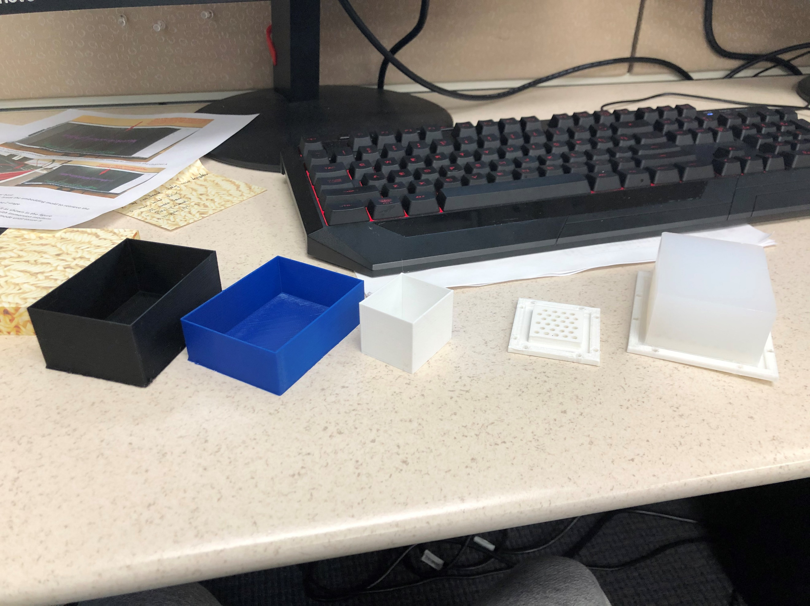

Step 2. Embed the sample with 4.5% agar. After agar solid, break the embedding mold to retrieve the sample block

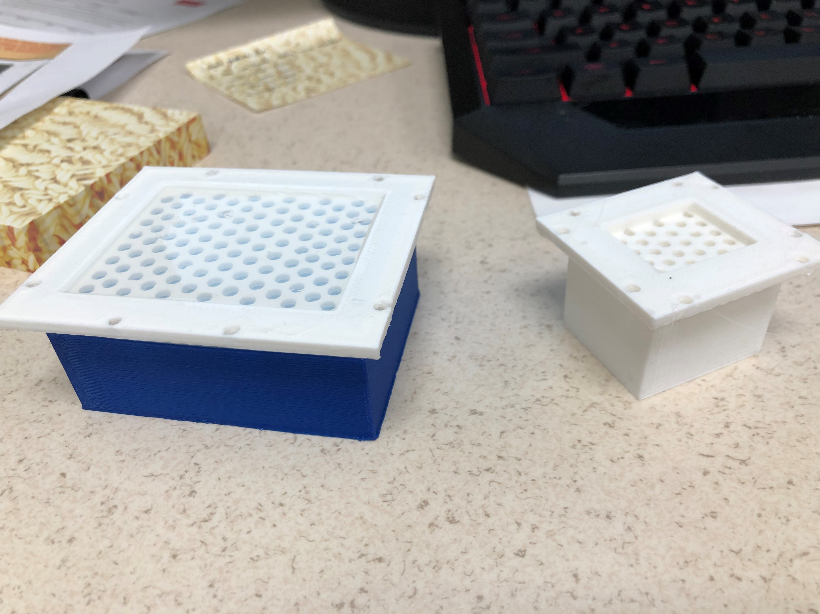 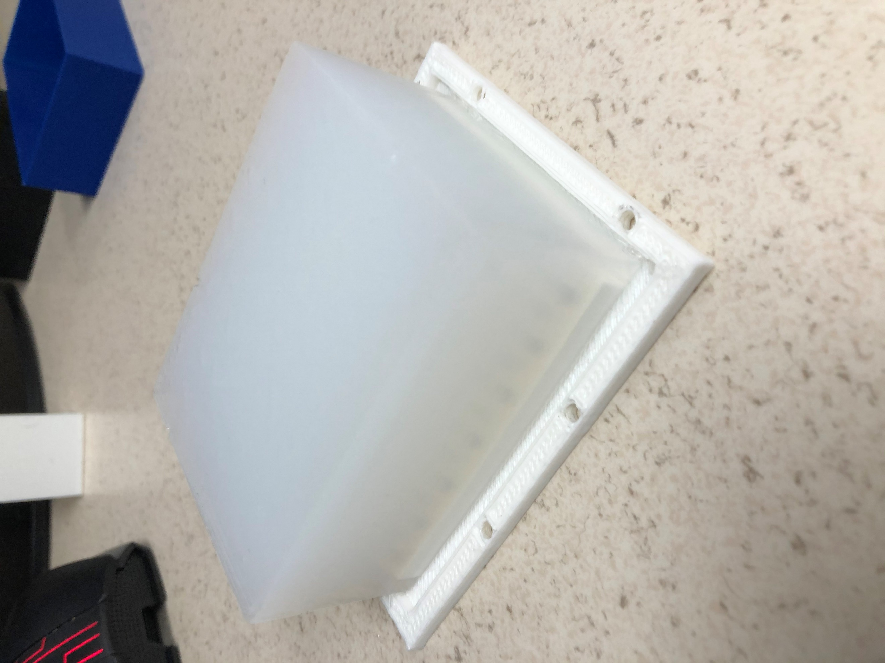

Step 3. Screw the sample block to the bath, mount the bath to the Z stage. You need to lower Z stage to 0 in order to mount the bath.

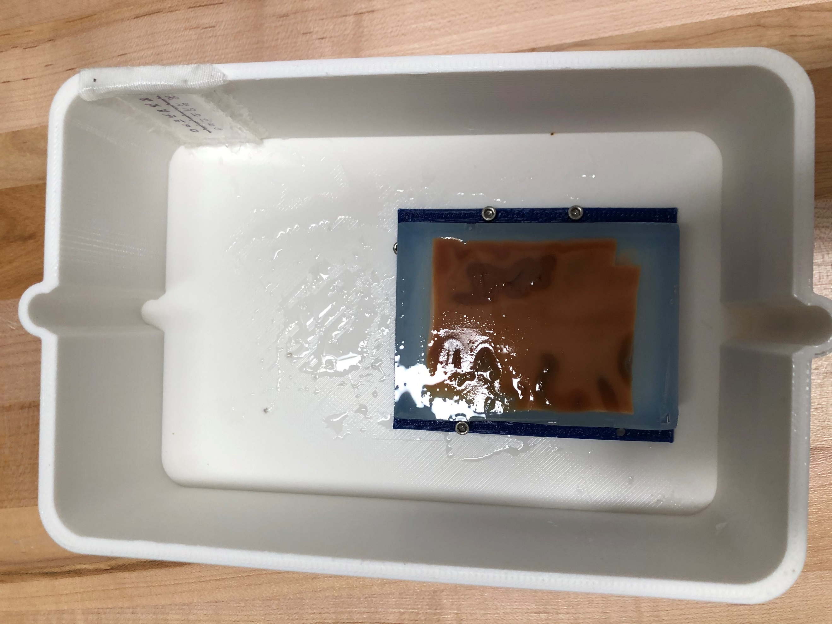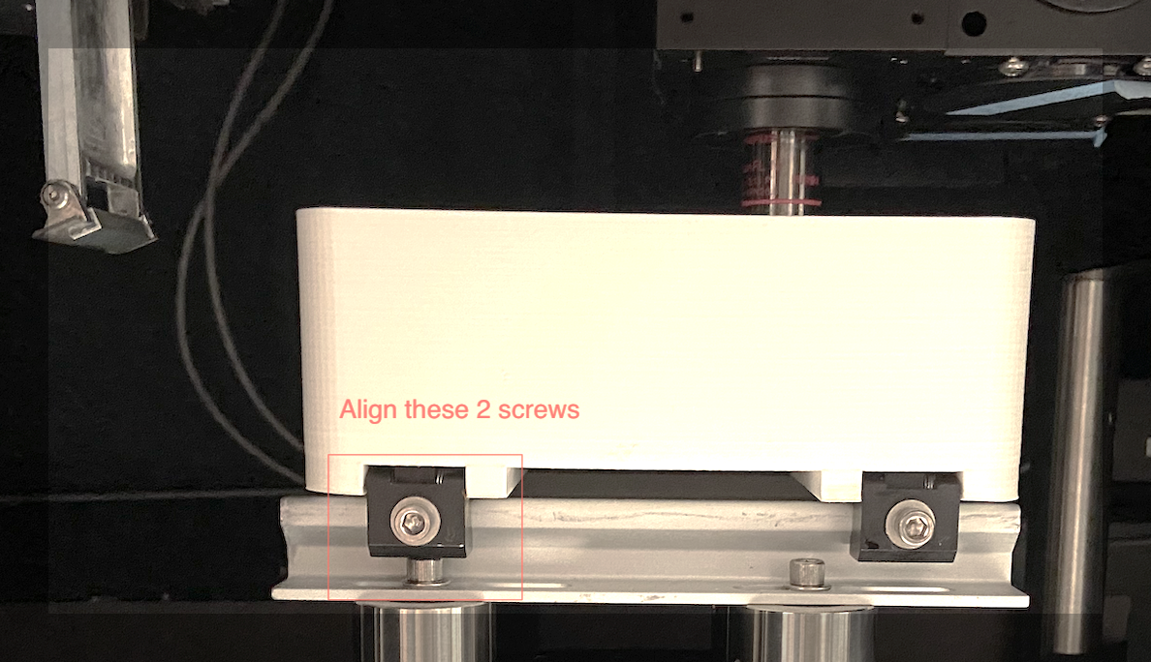

Step 4. Home each motorized stage in kinesis software (skip if you have done so this recently)

Step 5. Clean the objective spacer. **The spacer bottom is not flat but tilted, so orientation matters. Mount it with appropriate orientation, you should be able to find the orientation instruction sheet near the microscope system. The height, or how deep you push the spacer, also matters, it changes the focus depth. There should be a maker line on objective indicating how deep it should go in, match the spacer top with that line. If you see the internal reflection is overlapping with tissue signal, the spacer height is the only adjustment to correct for that.**

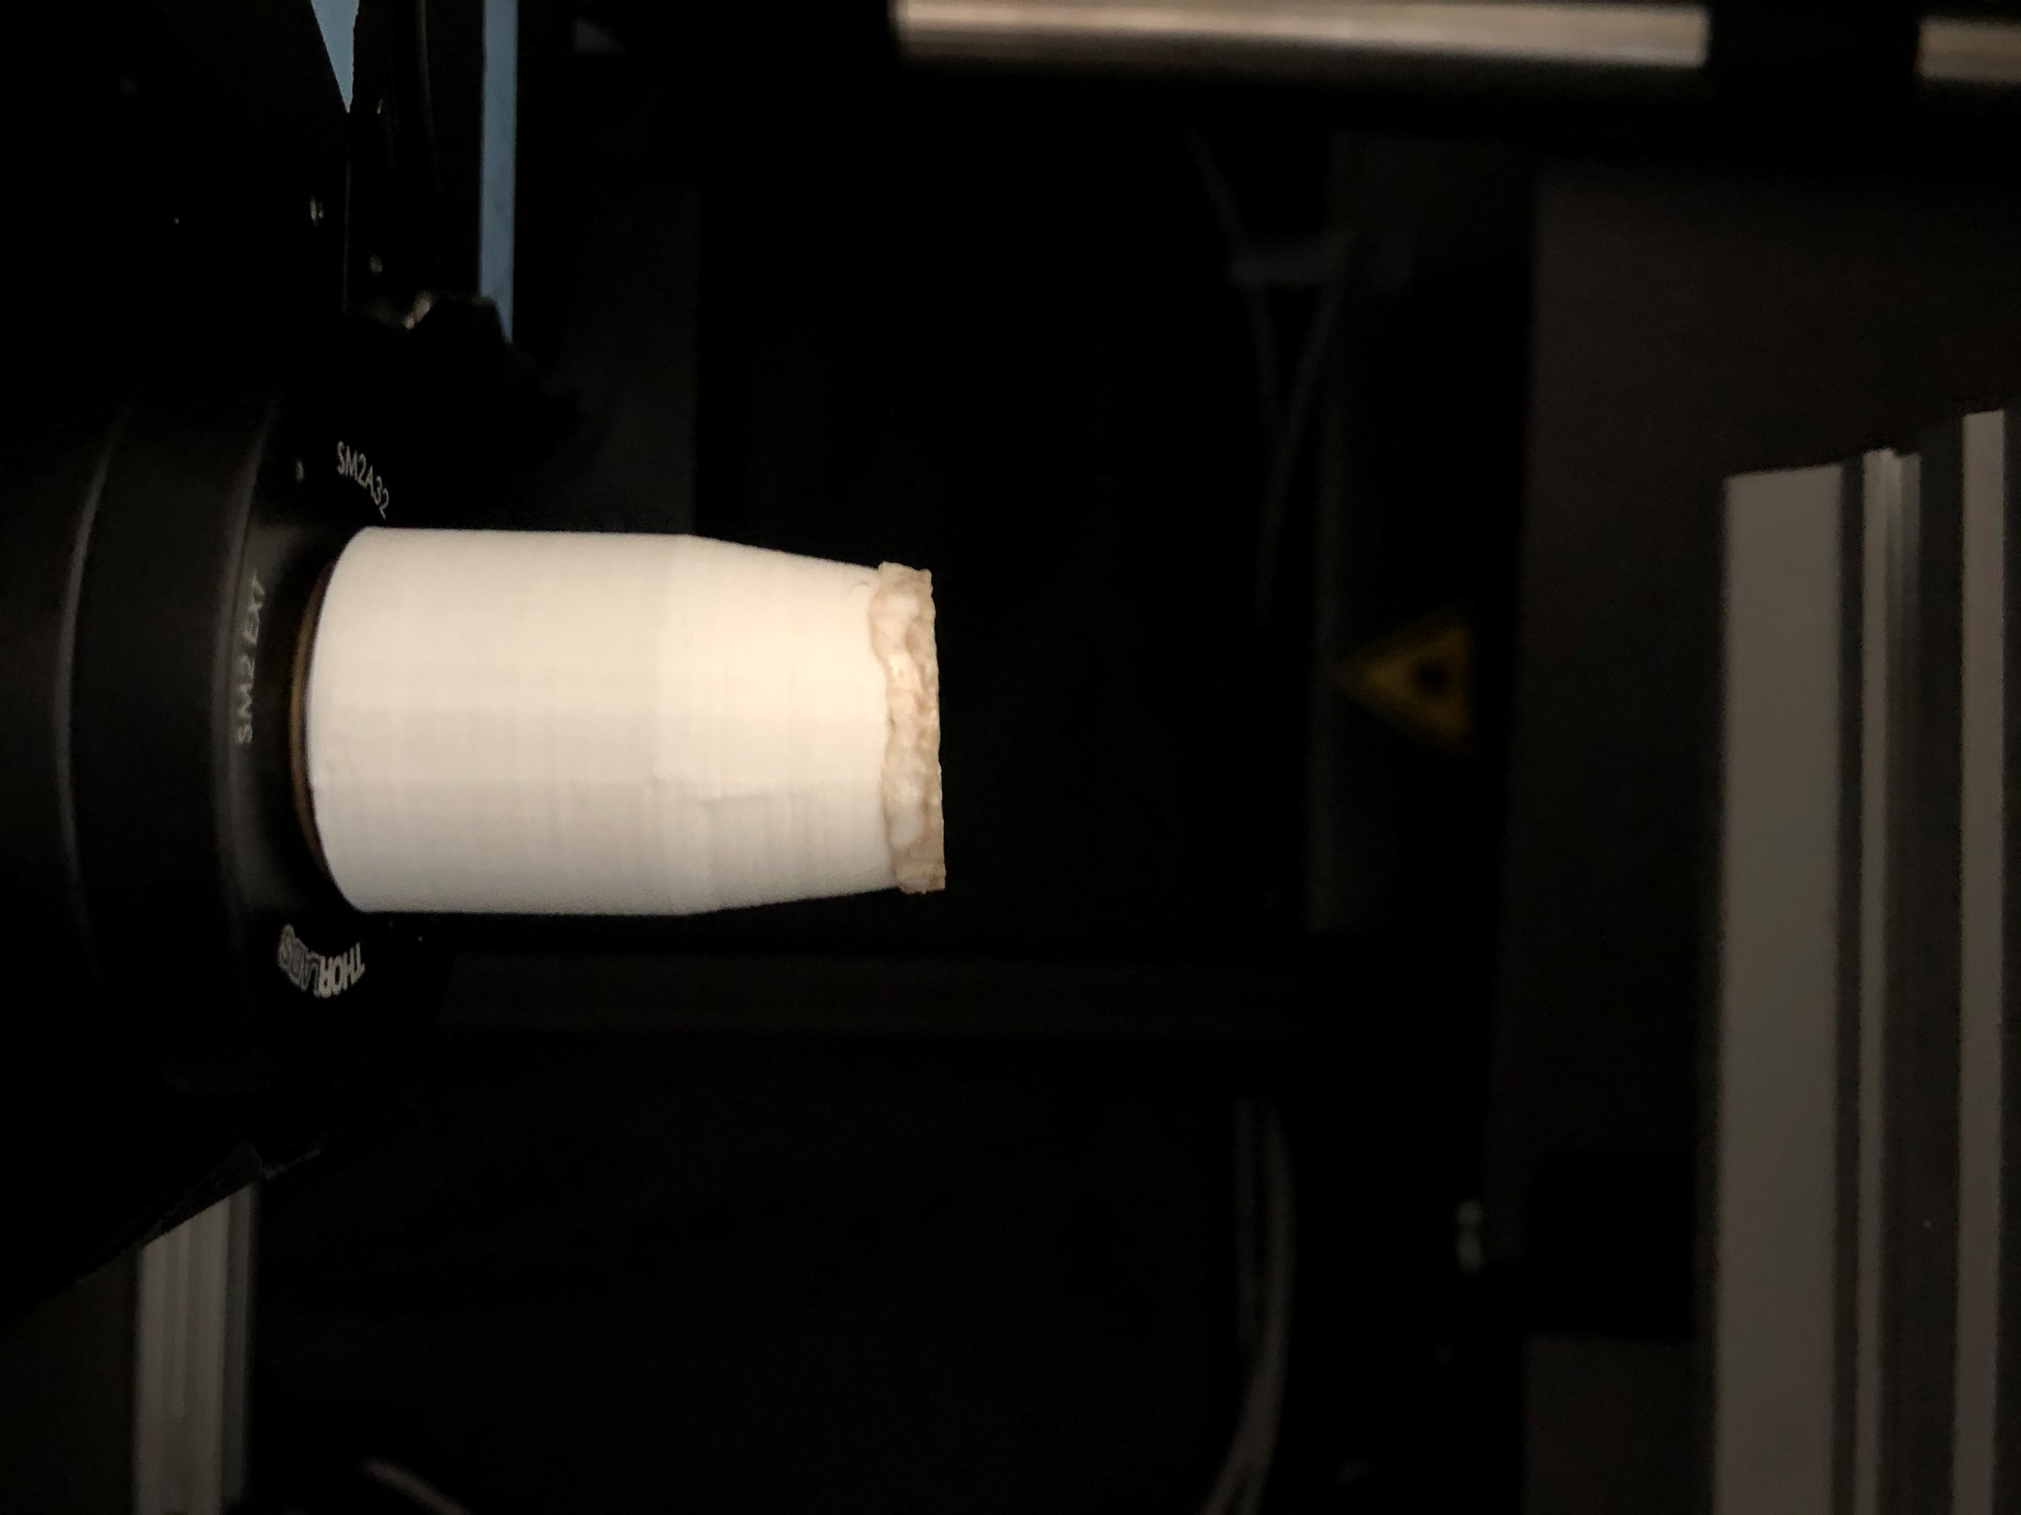

Step 6. Adjust the stages to the initial cut position.

* Press *Init Table* to initialize the stages (if wasn`t done previously). It should show numbers in cage rotator window after initialization.
* Move Z = 0. First enter position in the box then press “MOVE” button next to the box 2 times.
* Move Y = 100 (to avoid collision with a post)
* Move X = 250

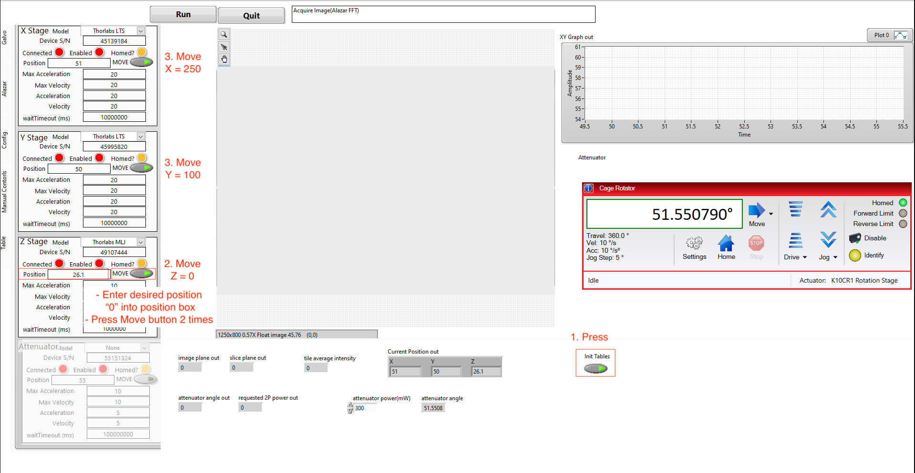

4.

* Gradually move Z stage up until the blade is cutting a thin slice off the surface.
* Immerse the sample with immersion medium (PBS or TDE). DO NOT use pump at this stage as it introduces bubbles. Fill up until blade is immersed in liquid.

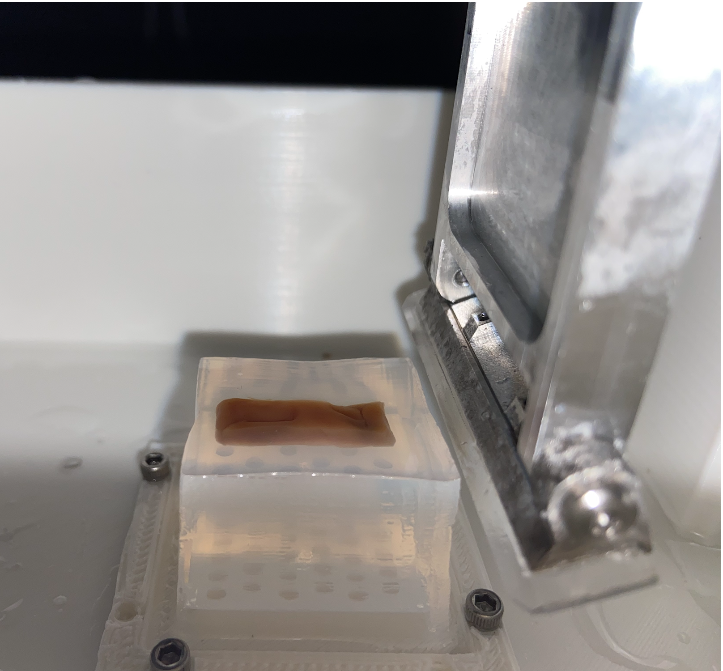

Step 7. Enter the cutting XYZ positions in **Config tab**, cut the superficial agar using vibratome mode (set in **Galvo tab**) until tissue is exposed. **Cutting height is defined by the *first cut height* in *Z stage settings*.** Write down last cutting Z position!

|  |  |  |
| --- | --- | --- |
|  |  |   1: enter cutting XY position (use current position output)  2: enter cutting Z position  3: enter random numbers (we don`t use this feature here)  4: set #cycles per rep to be 1  5: Click 2 times to disable pause  6: Set power to 200 |

1. Put sample in focus

Step 1. Move the sample to under objective

* Move Z = 0 -> Move X = 50 -> Move Y = 50 -> Adjust X to place center of the objective on top of the sample

Step 2. Move Z stage to put sample close to the objective cover, about 2-3mm from the bottom of cover

* Use following formula: imaging Z stage position = Last cutting Z position – 8 mm

Step 3. In **Galvo tab** set *Custom Y size* to be 20, set *continuous frame*, in **Manual Controls** panel choose *Alazar B-line*, choose channel B, set *#pixels to save* to be 800, disable *save data*, then click Run  
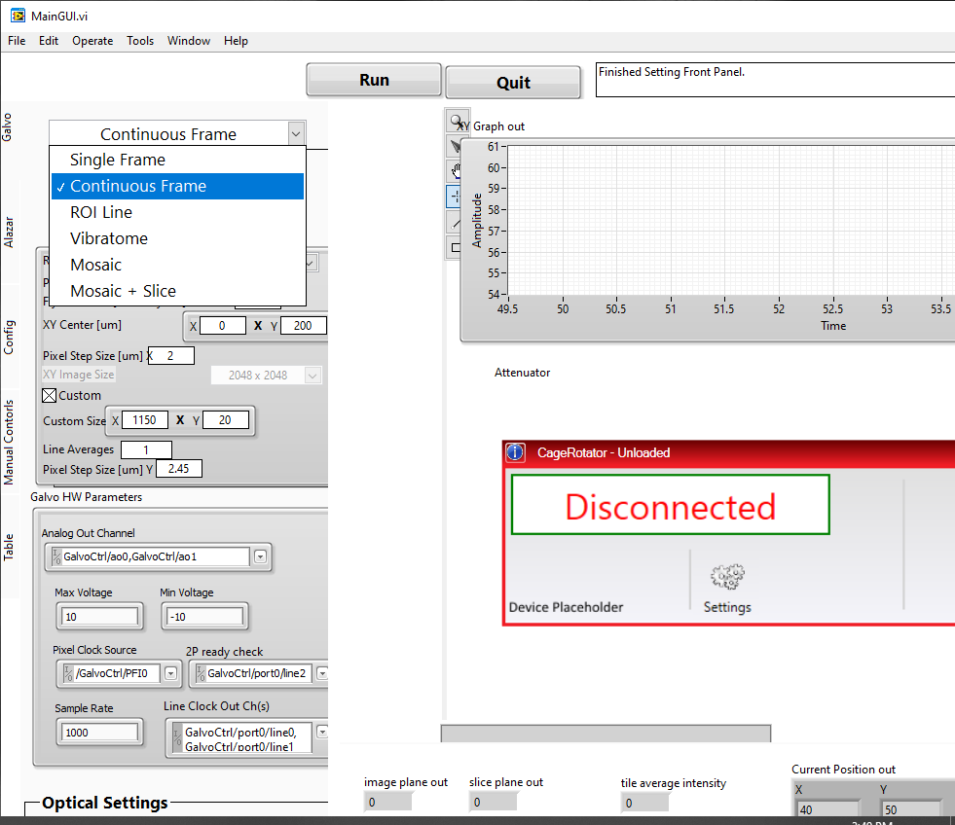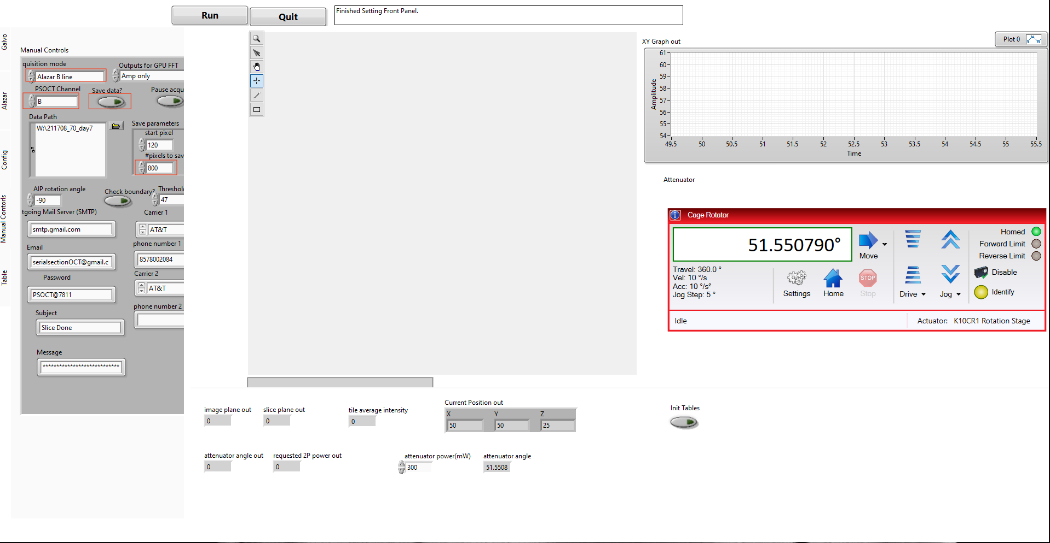

Step 4. Place sample in focus.

* Adjust the ref arm reflector to find the tissue signal (objective should be on top of the brain tissue).
* Once found, move the XY stages to image the agar (its low scattering allows you to visually see the focus depth). Fine-tune Z stage position and reflector to put sample in focus. You should get image similar to the one shown in fig below. (leave about 30-50 pixels empty at the top of B-line)
* Click Quit, in **Manual Controls tab** set *#pixels to save* as 300 and Run again, make sure signal filled in the B-line. Then Move XY stages to make sure tissue surface is smooth and captured by the 300 pixel depths. Check that sample is even and we have everywhere at least 30-50 pixels empty at the top of B-line.
* In **Config tab** enter the Z stage height to *first image height* in *Z stage settings*

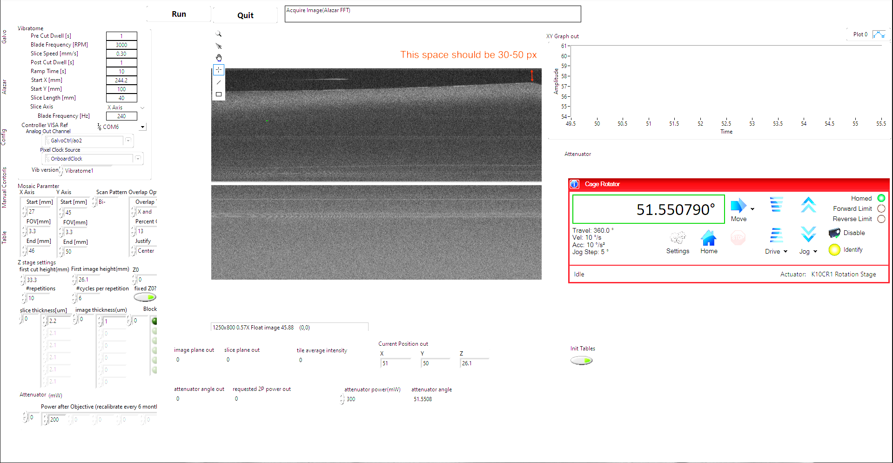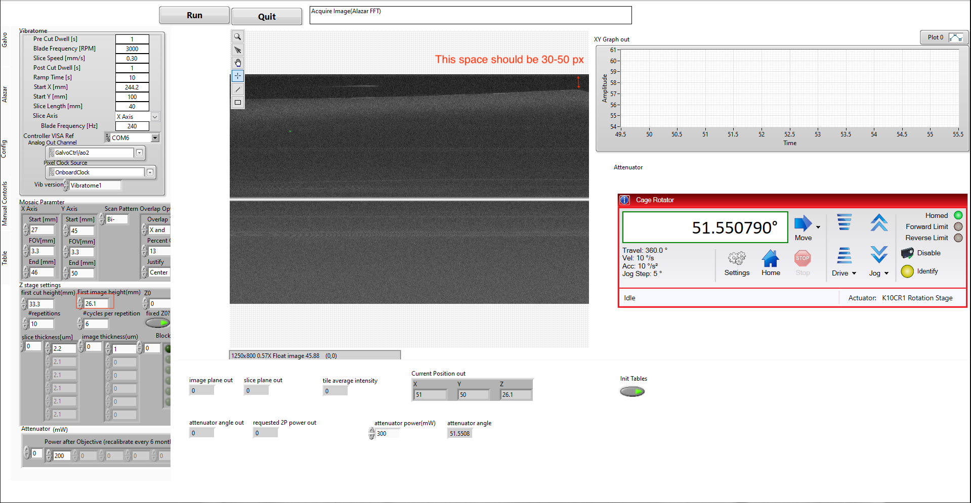

1. PSOCT Checking tissue boundary

Step 1. Stop and restart mainGUI. In **Galvo tab** set *Custom X&Y size* to be 300, *X step size* to be 10, *Y step size* to be 10, set *continuous frame*, in **Manual Controls tab** choose *Alazar FFT*, choose channel B. Check local_folder in Disk W:\, make sure there’s no data from previous experiment. Note: if you create a new data folder in W:\ instead of using the *local_folder* that’s already there, remember to configure the folder settings to allow access for all users. Otherwise, the server will not be able to access files there.

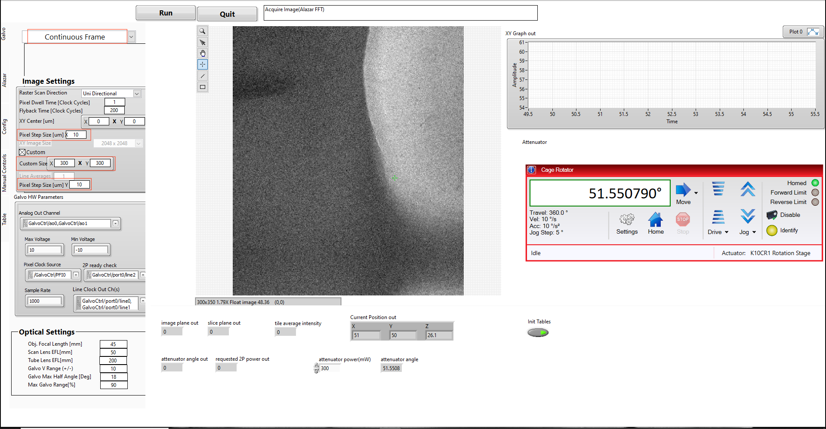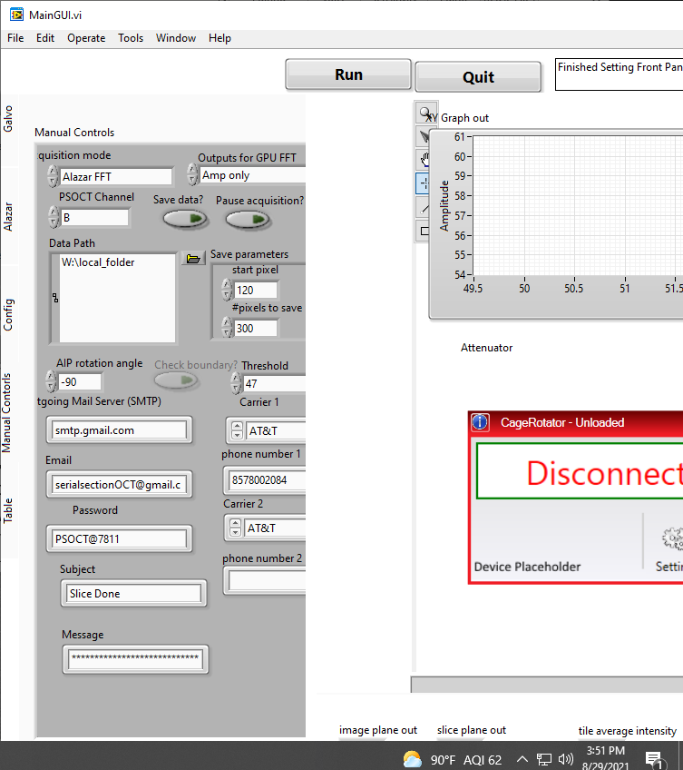

Step 2. Move XY stages to find the edge of tissue (as shown in fig below), enter the *start and stop X&Y positions* to *Mosaic Parameter*. Leave *FOV[mm]* and leave other parameters as default (if you use a different FOV than 3x3mm, you’ll have to change FOV[mm], Percent Overlap).

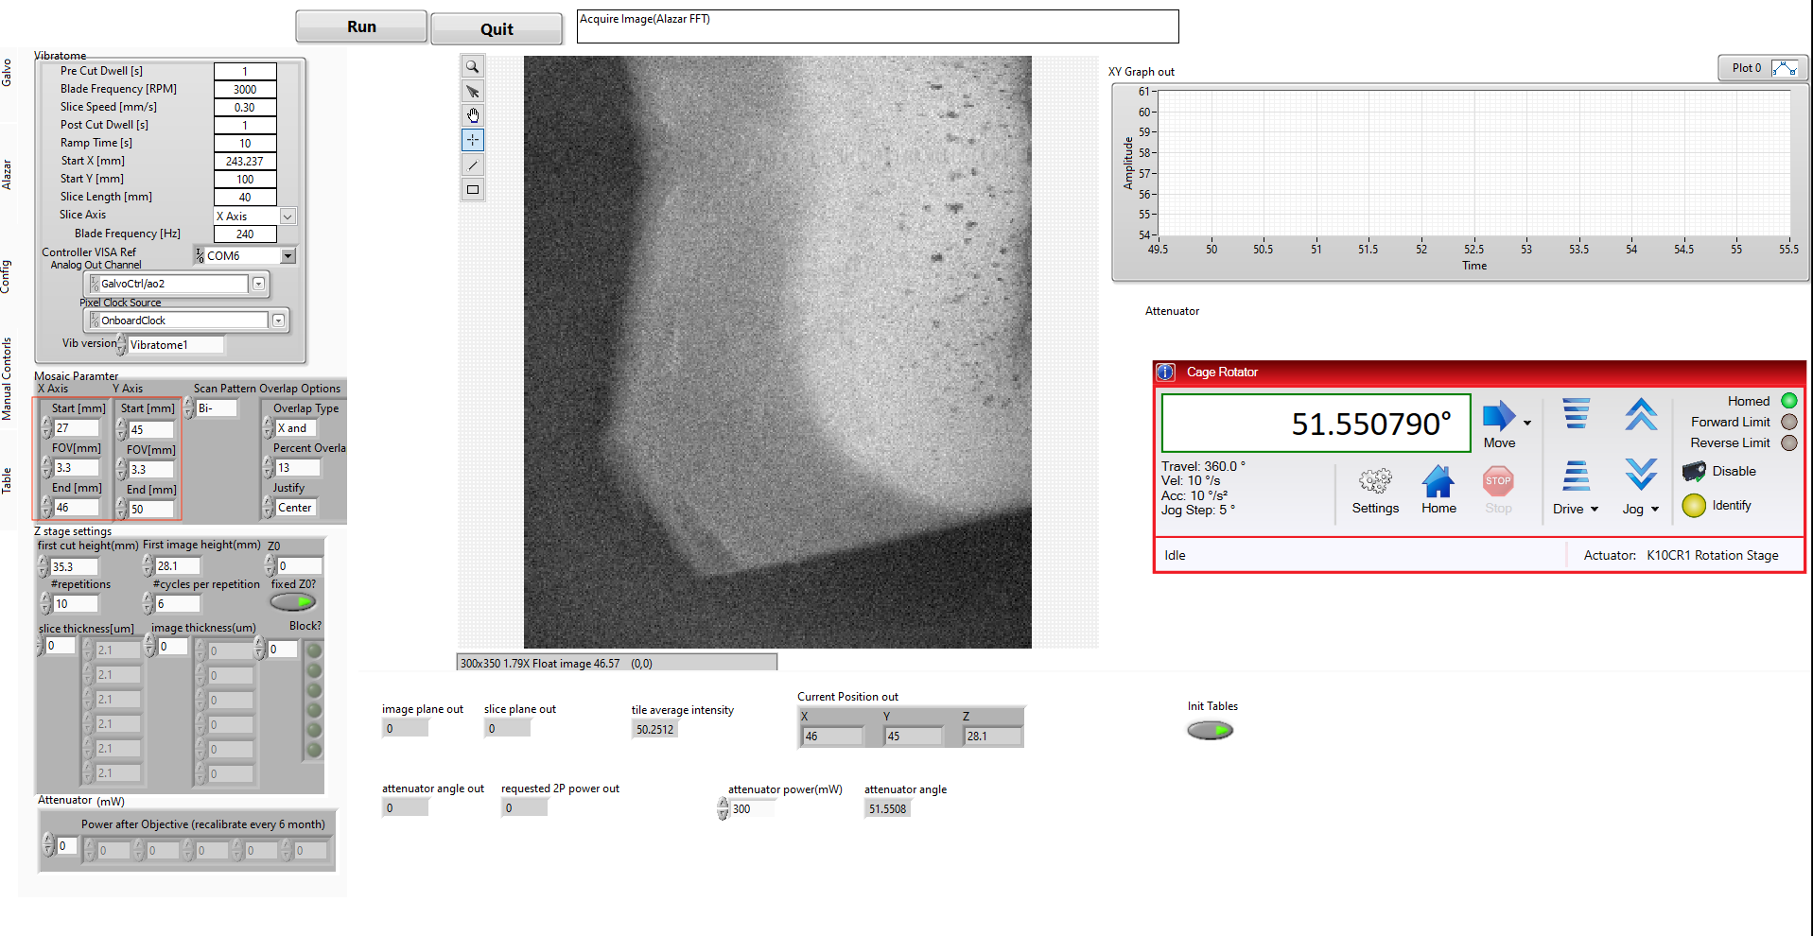

1. Setting 2P as slave and fine-tune focus

Step 1. Turn on the 2P laser by switch the key to on. After laser shows OK, open shutter (DO NOT open shutter immediately after key on)

Step 2. In 2P computer, open matlab, run “scanimage”, click continue. Load default settings, create a data folder in Data Disk (V:) and enter it in scanimage as file directory.

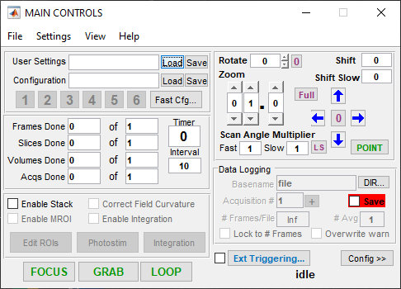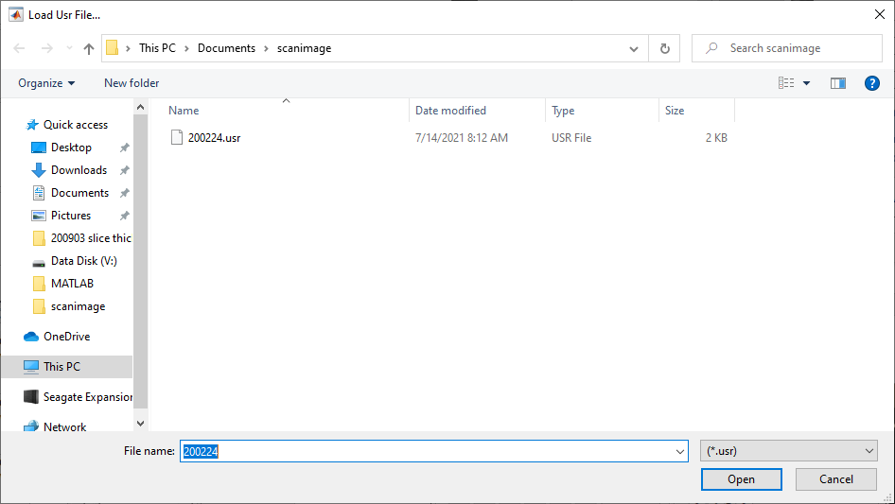

Step 3. Move XY stage to image gray matter. Click GRAB in Main Controls to grab an 2PM image. Move the Z stage up and down by 50um or so and take images at those positions as well. Compare those images and determine which is the best focus depth. Enter that focus depth to PSOCT computer->mainGUI->config->first image height.

Step 4. If you changed the first image height by a lot, you need to readjust the reference arm, making sure there’s 30-50 pixels above tissue signal.

Step 5, make a subfolder inside the 2PM data folder, change the default save folder to that new folder and click LOOP.

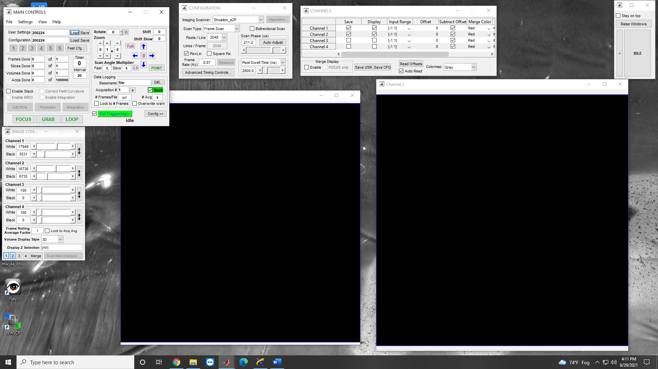

1. Setting up local server

Step 1. Connect the PSOCT computer keyboard to the local server. In Terminal navigate to ~/PycharmProjects/Braincache/

Step 2. Run “python data2SCC.py”

1. Setting up text message reminder

Step 1. Log in to gmail account [serialsectionoct@gmail.com](mailto:serialsectionoct@gmail.com), go to *manage your google account* -> *Security*->*Less secure app access*, make sure access is turned on.



1. If experiment is imaging the surface of tissue or a slice of tissue

Step 1. If using 2P, turn off room light. Close microscope curtain

Step 2. If using 2P, turn on PMT controller, using default voltage settings. Setting shutter to X gate mode and enable. Enter 90mW in attenuator power.

Step 3. In mainGUI, restart software, in **Galvo tab** choose *Mosaic mode*, set *custom X size* to be 1200 (or some other FOV size as you wish), *Y size* to be 1100 (or some other FOV size as you wish, the default gives you 3x3mm FOV), *X step size* to be 2.01, *Y step size* to be 2.47, *Init Tables*; in **Manual Controls tab** choose *GPU FFT*, choose Channels (A, B or A+B, depending on your application. For default choose A+B), choose Outputs for GPU FFT as Amp+Phase diff, set *Data Path* to be *local_folder*, enable *Save data?*, double check all settings; in **Config tab** set the first item in Z stage settings (random numbers to slice thickness, disable block, set power). Then run

|  |  |  |
| --- | --- | --- |
|  |  |  |

1. If experiment is imaging a block of tissue

Step 1. If using 2P, turn off room light. Close microscope curtain

Step 2. If using 2P, turn on PMT controller, using default voltage settings. Setting shutter to X gate mode and enable.

Step 3. In mainGUI, Quit and restart software, choose *Mosaic+Slice* mode, set *custom X size* to be 1200 (or some other FOV size as you wish), *Y size* to be 1100 (or some other FOV size as you wish, the default gives you 3x3mm FOV), *X step size* to be 2, *Y step size* to be 2.45. In manual control panel choose *GPU FFT*, choose Channels (A, B or A+B, depending on your application. For default choose A+B)

Step 4. If using 2P, depending on how many image depths per slice, enter the same number of attenuator powers. For 400um slice with 3 imaging depths, I use 90mW, 100mW and 120mW. Note the power-to-angle conversion is not very precise and is hard-coded. But you can check what angle a specific power setting corresponds to here:

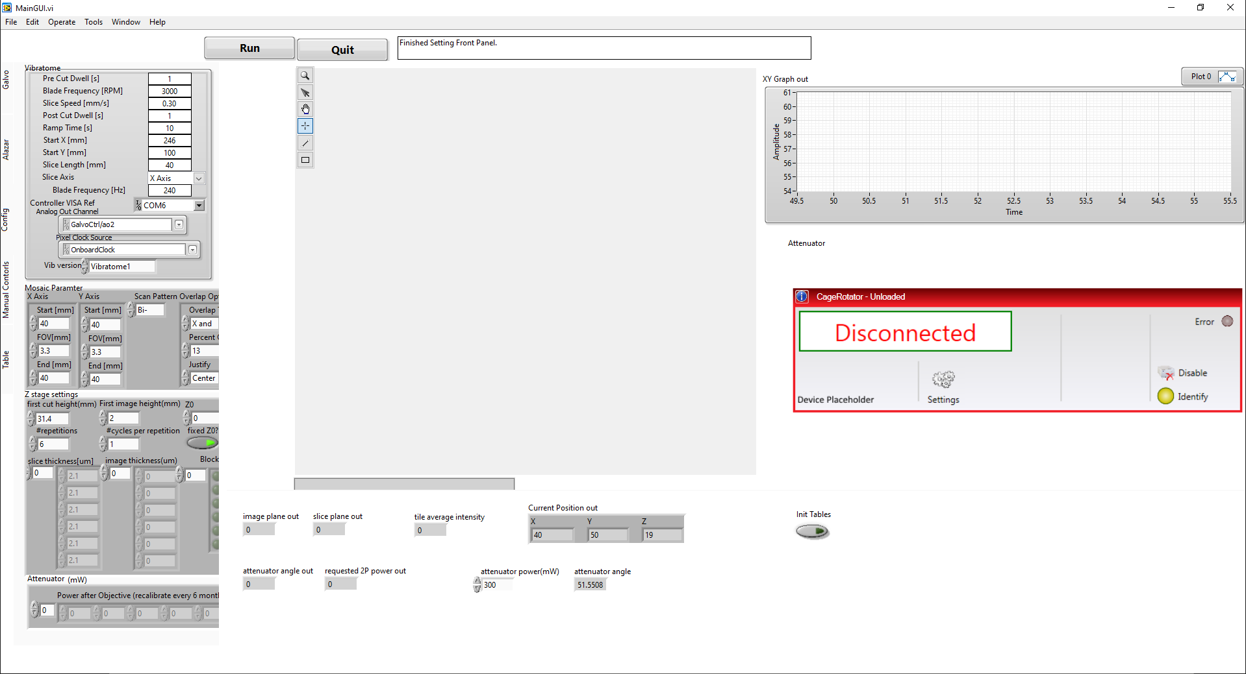

**Step 5.** Configure slice thickness and image thickness in *Z stage settings*. Here you really need the Z settings, so configure it carefully according to your experiment. Here I give a few examples to show how it works.

1. **For the U01 project I want to cut fifty 400um slices, each slice will be imaged three times, each time it focuses at increasing depth: 0-133um, 133-266um, 266-399um. And I want to pick up the slices in sequence.** The setting is shown in first figure. Note the *#cycles per rep* is equal to #items in the slice thickness array. Also note *#repetitions* * *#cycles per repetition* = total # slices. Also note the attenuator has three powers, equal to three imaging depth per slice. Also note the block? Button is turned on.
2. **For the collaboration with Prof. Bigio’s group, I want to cut a total of 30 slices, but I have different thickness requirements for these slices. I want 6 slices in a group, total of 5 groups. In each group, the first slice is 150um thick, the second 150um-slice should be cut 5 times, resulting in five 30um-slices. The third 150um slice should be cut 3 times, resulting in three 50um-slices. The rest three 150um slices will stay 150um thickness. I want to pick up the 30um slices, 50um slices in sequence, but I don’t care about other slices. The setting is shown in the second figure.** Note the *#cycles per rep* is equal to #items in the slice thickness array. Also note *#repetitions * #cycles per repetition* = total # slices. Also note the second and third 150um have light buttons means the system will be paused prior to cut these slices, waiting for you to pick up them. Also note there’s only 1 attenuator power, because each slice is imaged only once.
3. **For a testing sample, I want to cut 20x 150um slices, I don’t pick up any slices.**

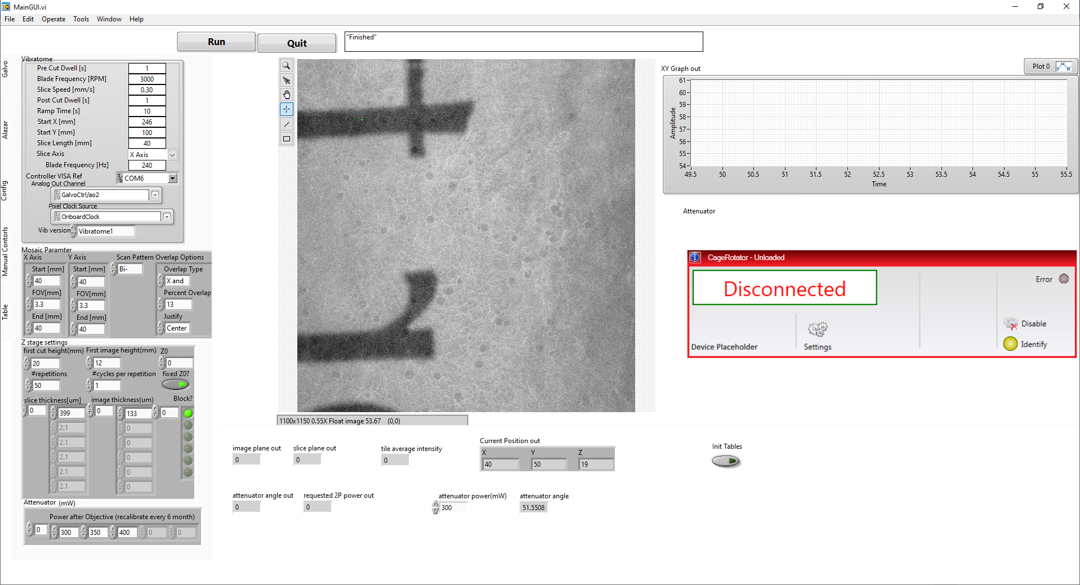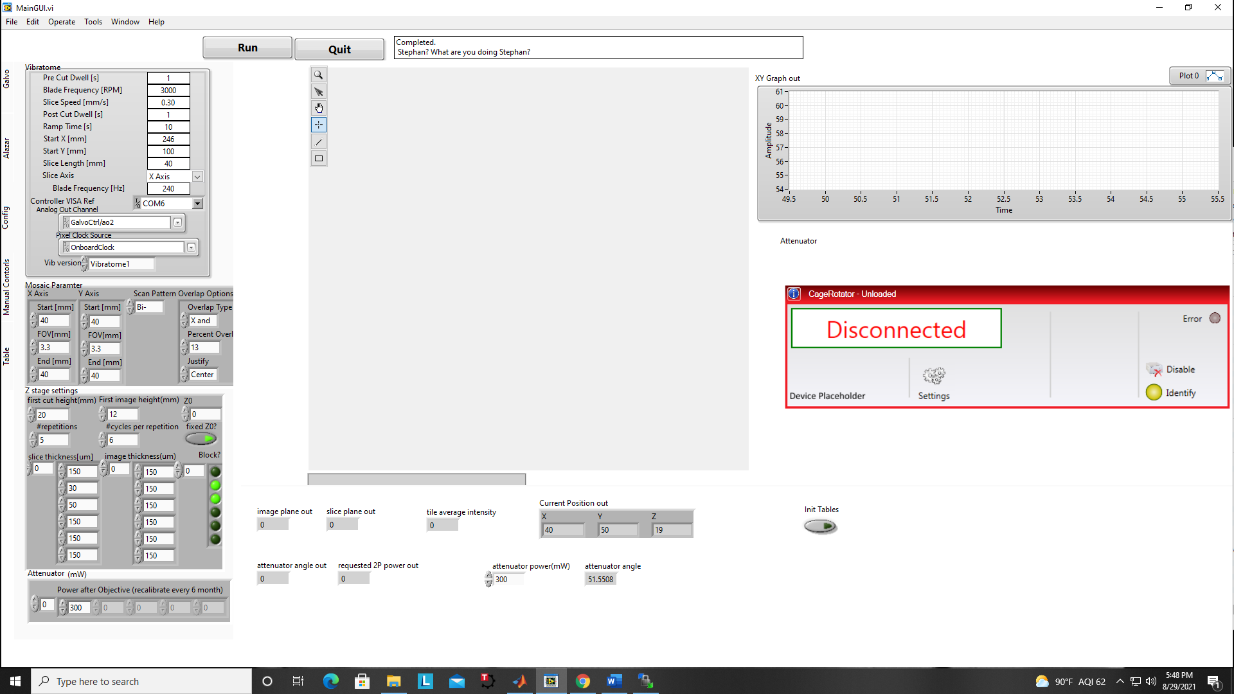 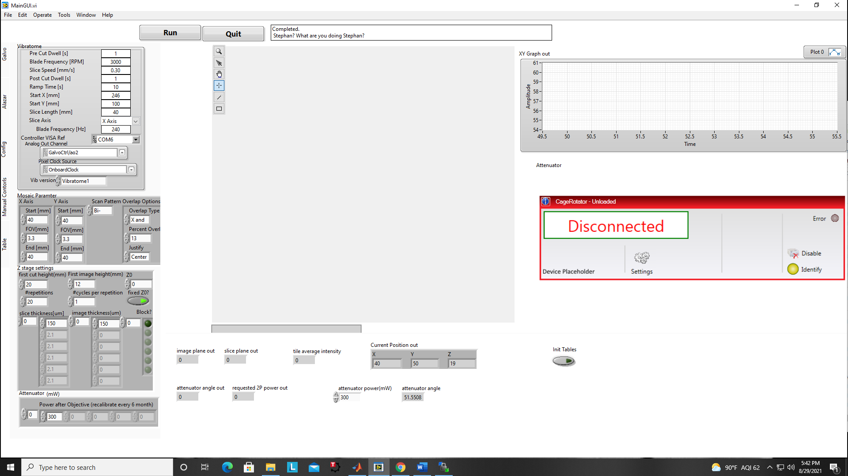Note that if the settings are not right, the software will detect an error and prevent you from running experiment.

c.

b.

a.

Step 6. If you want text message reminder to pick up the slices, in *Manual Control* choose your phone carrier (ATT, T-mobile, etc) and enter your phone number. There are two phone number entries, allowing at most two people to be alerted.

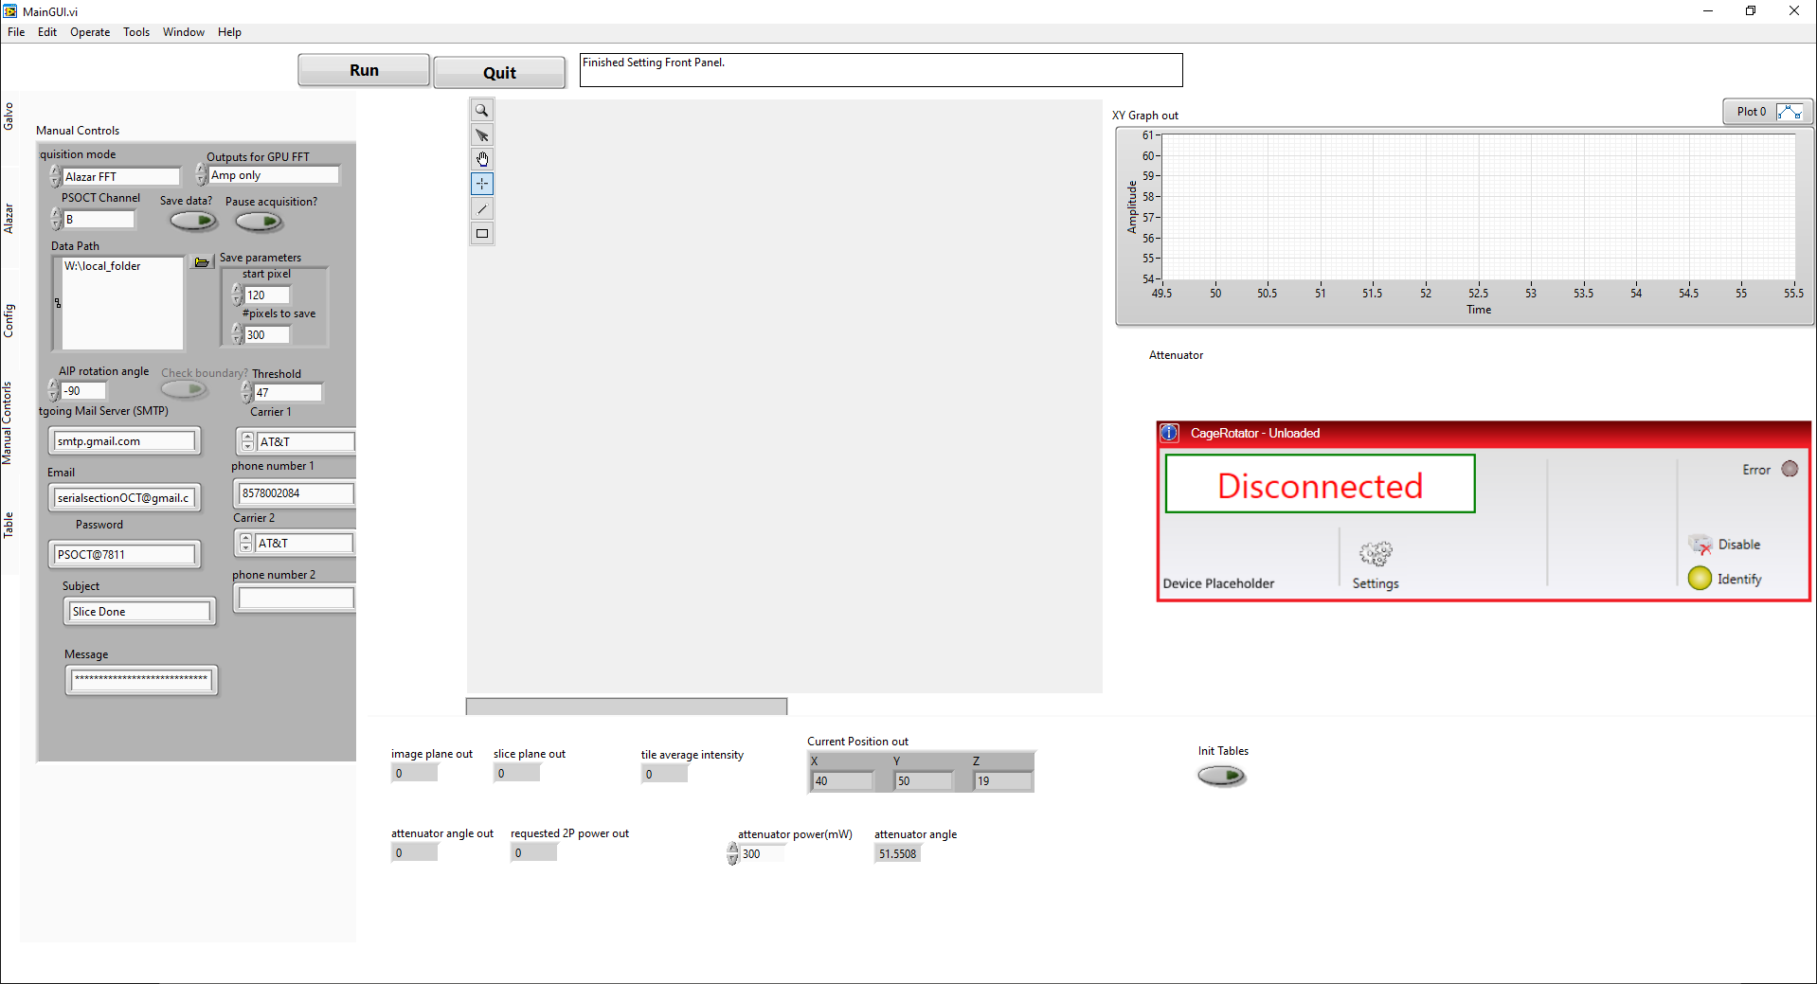

Step 7. Choose GPU FFT, choose Channels (A, B or A+B), click *Save Data?* if you want to save the data, double check all settings and click Run.

Manual actions during Mosaic and slicing

1. To collect slices during imaging, make sure the software is paused automatically by checking the message box in mainGUI. If it says *Acquisition paused* then you are good to do the next. Turn off both PMT controllers, then you may turn on room light. Open the curtain and collect slices in the bath. After that click the *Pause Acquisition* button in mainGUI **twice,** then vibratome will cut the next slice. Click *Pause Acquisition* button in mainGUI **twice** and pick up slice, repeat this step a couple times until every slice is cut and picked up. Lastly close the curtain, turn off room light and turn on the PMT controllers. Click *Pause Acquisition* button in mainGUI **twice** the last time to resume imaging.
2. After finishing experiment, turn off PMT controllers, turn off light source for PSOCT and 2P laser, turn off variable retarder. Enter 0 to the local server to stop the data pushing. After all data is transferred to SCC, go to winscp and navigate to /projectnb/npbssmic/ns, rename the remote_folder, and make a new remote_folder for next experiment.
3. 